“ ЗАТВЕРДЖЕНО”
на методичній нараді кафедри
дитячої хірургії протокол № 1
від 10 січня 2018 року
Зав. кафедрою дитячої хірургії
професор_______________А.Ф. Левицький

Theme No 3
Abdominal wall defects. Gastroschisis, omphalocele. Rare abdominal wall defects

Compilers:
Associate professor of pediatric surgery department Benzar Iryna

Overview:
Abdominal wall defects offer great insight into normal fetal development and present unique challenges to pediatric surgeons. Gastroschisis and omphalocele are among the most frequently encountered congenital anomalies in pediatric surgery. Combined incidence of these anomalies is 1 in 2000 births, which means, for example, that a pediatric surgeon will see 2 such babies for every 1 born with esophageal atresia or tracheoesophageal fistula. This theme describes various abdominal wall defects, their prognosis, surgical- and long-term prospects, possible management, and considerations for pain control. A case scenario also tests student understanding of the material.

Educational aims:
After completing this part of module students should be able to:
- Recognise the main features of gastroschisis and omphalocele in newborn children
- Counsel parents about the likely diagnoses and management
- Know what the possible complications are
- Know the indications for urgent treatment or referral to a specialist center
- Know the outcome of abdominal wall defect
- Recognise of complications.
- Discuss the overall prognosis and management of gastroschisis and omphalocele

A student must know:
- Embryology of the abdominal wall
- Embryogenesis of the abdominal wall defects
- Antenatal considerations of the abdominal wall defects
- Incidence and associated conditions
- Pathogenesis of omphalocele and gastroschisis
- Prenatal diagnostic procedures.
- Clinical features of omphalocele and gastroschisis
- Preoperative treatment
- Modern approach to abdominal wall closure
- Complications of abdominal wall defects

A student must be able to:
- Describe the clinical features of abdominal wall defects
- Evaluate the prenatal ultrasound and MRI investigations
- Evaluate the prenatal screening laboratory tests
- Take care for children with silo sac
- Analyze the blood tests to evaluate the type of coagulopathy.
- Appoint additional investigations in children with abdominal wall defects

Terminology
Term | Definition
Omphalocele (exomphalos) | herniation of intraabdominal contents through a full-thickness umbilical defect which is covered by a sac composed of peritoneum internally and umbilical cord amnion externally.
Gastroschisis | defect in the abdominal wall usually just to the right of the umbilicus. The herniated viscera are not covered by a sac
Beckwith-Wiedemann syndrome | exomphalos, macroglossia, gigantism
Pentalogy of Cantrell | anterior diaphragm and pericardial defects, a short bifid sternum, and cardiac defects associated with an omphalocele sac or, at least, hypotrophic epigastric skin
Bladder exstrophy | Abnormal development of the lower body wall results from defective enfolding of the caudal pole of the embryo and deficient incorporation of the yolk sac and allantois; this is associated with malformation of external genitalia
Prune belly (Eagle Barrett) syndrome | Rare congenital abnormalities, is a result of increased apoptotic cell death in the body wall placode, which leads to insufficient mesodermal cell deposition. Muscle fibers are absent and replaced by a thick collagenous aponeurosis.

CONTENT
Congenital abdominal wall defects include gastroschisis, omphalocele, hernia of the umbilical cord, cloacal exstrophy (infraumbilical omphalocele, exstrophy of the bladder, imperforate anus), Cantrell’s Pentalogy (supraumbilical omphalocele, sternal cleft, intracardiac anomaly, diaphragmatic hernia, and pericardial defect), and prune belly (Eagle Barrett) syndrome. Gastroschisis and omphalocele represent two distinct congenital abnormalities of the anterior abdominal wall.

Gastroschisis and omphalocele
The term gastroschisis (“belly cleft”) was coined in 1894 by Italian pathologist Cesare Taruffi, who used it in “Storia della Teratologia” to define a variety of congenital malformations in which the abdomen remains open at birth, though the condition had been reported sporadically since 1557. Omphalocele is described in the sixteenth century printed . works of Ambrose Pare. The first successful repair of omphalocele was reported by Hey in 1802.9 In 1873 Visick escribed the successful repair of gastroschisis.
Omphalocele (Gr. omphalos – umbilicus + Gr. kele –swelling; hernia; syn. Exomphalos) is central abdominal wall defect that permits herniation of abdominal viscera into the umbilical cord. Gastroschisis is a smaller abdominal wall defect to the right of a normally positioned umbilical cord, which permits herniation of intestine.
Embryology. The human embryo initially is disc-shaped and composed of 2 cell layers. It acquires a third cell layer as it grows above the umbilical ring and becomes cylindrical by elongation and inward folding. The body folds (cephalic, caudal, lateral) meet in the center of the embryo where the amnion invests the yolk sac. Defective development at this critical location results in a spectrum of abdominal wall defects. By the sixth week, rapid growth of the midgut causes a physiologic hernia of the intestine through the umbilical ring. The intestine returns to the abdominal cavity during the tenth week, and rotation and fixation of the midgut occur. This process does not occur in babies with gastroschisis or omphalocele, resulting in an increased risk of midgut volvulus.
Pathogenesis of omphalocele and gastroschisis
Abdominal wall defects occur as a result of failure of the mesoderm to replace the body stalk, which persists in a region normally occupied by somatopleure. Embryonic dysplasia causes insufficient outgrowth at the umbilical ring. Decreased apoptotic cell death and underdevelopment of the mesodermal cell compartment cause enlargement of the umbilical ring’s diameter. The amnion does not apply itself to the yolk sac or connecting stalk but remains at the margin of the body wall defect, causing faulty development of the umbilical cord and a persistent communication between the intraembryonic body cavity and the extraembryonic coelom.
In babies with omphalocele, failure of central fusion at the umbilical ring by growth of the mesoderm causes defective abdominal wall closure and persistent herniation of the midgut.
Gastroschisis is one of several congenital abdominal wall defects that evolves in the first four post-conception weeks. It is generally accepted that this congenital abdominal wall defect is embryologically different from omphalocele. The anomaly is thought to be the result of a defect at the site where the second umbilical vein involutes. Nonrotation of the bowel always accompanies this anomaly and there is an increase in intestinal abnormalities including atresia (mostly involving the small intestine) perforation, and infarction resulting from in utero midgut volvulus or vascular thrombosis. However, unlike omphalocele, there is no increase in anomalies of other organs.
Frequency. Omphalocele occurs in one out of 4000 live births, and gastroschisis occurs in one out of 6000–10 000 live births. The incidence of gastroschisis around the world has been increasing over the past 30 years, while the incidence of omphalocele has remained relatively constant. Gastroschisis appears to occur more commonly in young mothers, especially those younger than 20 years of age.

Prenatal diagnostic procedures.
Lab studies. Elevated alpha fetoprotein (AFP) in both maternal serum and amniotic fluid and elevated amniotic fluid acetylcholinesterase (AChE) have been correlated with abdominal wall defects when there is no myelomeningocele. AChE was elevated in 80% of pregnancies with gastroschisis and 27% of those with omphaloceles. Maternal serum alphafetoprotein is elevated in 90% of mothers carrying babies with omphalocele, and 100% of those with gastroschisis.
Imaging studies.
The unique anatomic characteristics of omphalocele and gastroschisis allow them to be identified and differentiated using prenatal ultrasound. Omphalocele can be distinguished from gastroschisis by the presence of a sac and from umbilical cord hernia by the presence of the liver in the defect.
Once an abdominal wall defect is identified, a search for additional anomalies should be carried out. If the problem is clearly gastroschisis, this can be limited to a careful anatomic ultrasound. For fetuses with omphalocele, both structural and chromosomal problems should be sought. Karyotype analysis by amniocentesis or chorionic villous sampling, and anatomic ultrasound, including fetal echocardiography, should be completed. Fetal echocardiography also may identify a cardiac abnormality.

Obstetric Delivery
The timing, location, and mode of delivery may impact on the outcome of infants with omphalocele and gastroschisis. Most infants with omphalocele should be delivered at term. In contrast, infants with gastroschisis may benefit from early delivery to minimize the damage from exposure of the bowel to amniotic fluid. Use of routine cesarian delivery for both omphalocele and gastroschisis also remains controversial. There is general agreement that infants with a very large omphalocele should be delivered in this manner to prevent injury to the exteriorized liver, however infants with smaller defects should probably be delivered by vaginal delivery unless there are obstetric indications for cesarian section.
With very few exceptions, all infants with an abdominal wall defect should be delivered at a perinatal center, where immediate neonatal and surgical expertise are available.

Physical examinations: Gastroschisis
The abdominal wall defect is fairly uniform in size and location: a 3-5cm vertical opening immediately to the right and inferior of the umbilical cord. All patients with gastroschisis have intestinal nonrotation. The stomach, small and large intestines and occasionally the gonads can be found outside of the abdominal wall. The liver is almost never eviscerated. There is no peritoneal sac over the herniated contents. Therefore, the bowel is subjected to amniotic fluid (pH 7.0), which later in pregnancy becomes irritating and results in a thick fibrotic inflammatory peel over the eviscerated bowel. Another proposed cause of the thickened, inflamed bowel is the constriction of the abdominal wall defect late in gestation leading to venous congestion. Inflamed intestine is thick and edematous, the loops of bowel are matted together, and the mesentery is congested and foreshortened.
Histologically, atrophy of the myenteric ganglion cells is seen.
The intestine is dysmotile, with prolonged transit time and decreased absorption of carbohydrate, fat, and protein. These deleterious effects remit as the inflammation resolves, usually in 4-6 weeks.
Although the etiology is unclear, patients with gastroschisis sustain intrauterine growth retardation. The typical birth weight for these infants is between 2,000–2,500 g.
Gastroschisis is rarely associated with abnormalities outside the gastrointestinal system. Atresia, often resulting from local ischaemia at the neck of the sac, is by far the most common abnormality associated with gastroschisis, with an incidence of between 11 and 23 per cent.

Physical examinations: Omphalocele
Omphalocele represents a wide spectrum of pathology ranging from an uncomplicated hernia of the umbilical cord to a large defect with extrusion of all abdominal viscera (giant omphalocele) and life threatening associated anomalies. The abdominal wall defect can range in size from 2–10 cm. Virtually all intraabdominal structures can be eviscerated including the liver. The omphalocele is covered by an outer layer of amnion, a middle layer of Wharton’s jelly, and an inner layer of peritoneum. This robust covering protects the gastrointestinal tract during intrauterine life and bowel function is usually normal at birth.
Multiple anomalies are seen in 40–70% of infants with omphaloceles. Cardiac anomalies are present in 50% of cases (septal defects, tetralogy of Fallot, ectopia cordis). Gastrointestinal anomalies can occur (e.g. duodenal atresia, etc.). Chromosomal anomalies are seen in 30–40% of omphalocele cases (trisomy 13–15, 16–18, 21, Turner’s syndrome, Klinefelter’s syndrome, and triploidy).
Syndrome omphaloceles
Beckwith-Wiedemann syndrome
Babies with the Beckwith-Wiedemann syndrome (ie, exomphalos, macroglossia, gigantism) have large, rounded facial features, hypoglycemia from hyperplasia of the pancreatic islet cells, and visceromegaly. They may have genitourinary abnormalities, and they are at risk for development of Wilms tumors, liver tumors (hepatoblastoma), and adrenocortical neoplasms. The principal danger in these patients is postnatal hypoglycaemia (due to pancreatic islet hyperplasia) causing cerebral damage. Early administration of glucose can prevent serious sequelae.
Pentalogy of Cantrell
This malformation of the upper abdominal fold involves anterior diaphragm and pericardial defects, a short bifid sternum, and cardiac defects associated with an omphalocele sac or, at least, hypotrophic epigastric skin. Coverage of the omphalocele during evaluation of the cardiac defects allows subsequent complete repair of cardiac, diaphragmatic, and pericardial defects.
Vesicointestinal fissure (cloacal extrophy)
This malformation of the lower fold has an inferior-sited omphalocele, exstrophy of the cecum between the hemibladders, diastasis of the symphysis pubis, a short distal colon, no rectum, a shortened small bowel, and, occasionally, meningosacral anomalies. Many infants now survive following multiple corrective intestinal and urinary tract procedures.

Treatment
Gastroschisis
Initial care. As a result of the absence of a hernia sac and exposure of the eviscerated contents to fluid and evaporative heat loss, infants with gastroschisis will have profound fl uid and temperature regulation difficulties upon delivery. After addressing any airway, breathing or circulation issues, immediate placement of the lower half of the infant into a sterile bowel bag will ameliorate the fluid and heat losses. A nasogastric tube should be placed to facilitate decompression of the gastrointestinal tract. Empiric parenteral antibiotics with broad spectrum coverage are administered. Fluid resuscitationn should be guided by hemodynamic status, urine output, tissue perfusion, and correction of metabolic acidosis (if present). An initial fl uid bolus of 20 ml/kg.
Once adequate urine output is obtained and any acidosis corrected, the newborn can undergo either primary closure of the abdominal defect or temporary silo placement.
Operative closure. Primary closure should be attempted whenever feasible. Peak inspiratory pressures greater than 25 mmHg, increases in central venous pressure of 4 mmHg or more, and elevated bladder pressures greater than 20 mmHg upon fascial apposition should steer the surgeon away from performing primary closure. If the viscera do not fit into the abdomen without a significant increase in intra-abdominal pressure, a silastic ‘silo’ can be placed and the herniated contents gradually reduced back into the abdomen over the next 1–10 days. The contents of the silo should be reduced every 12–24 hours as tolerated by the baby. When the viscera have been successfully returned to the abdomen, the infant is taken to the operating room, the silo is removed, and the fascia is closed along with the overlying skin.
Complications. All gastroschisis patients will have some degree of postoperative ileus. While awaiting return of bowel function, gastroschisis patients will require parenteral nutrition via a central venous access thus subjecting them to risks like catheter sepsis. Ten percent of patients with gastroschisis will have persistent bowel hypoperistalsis and some infants will require long term parenteral nutrition.
Gastroschisis, complicated by intestinal atresia or perforation, can result in short bowel syndrome.

Treatment: Omphalocele
Initial care. Although the bowel in omphalocele is protected by the sac, operation is still urgently needed to increase the chance for primary closure. A nasogastric (NG) tube should be placed early to decompress the intestines. A rectal examination aids this with evacuation of meconium. Maintenance of body temperature is especially important. Ventilator support and supplemental oxygen should be supplied as needed. Because of the frequency of associated heart defects, cardiology evaluation and echocardiography are in order.
Operative closure. In the operating room the sac and abdomen are prepared with an antiseptic and excess cord is removed. The operative strategy for the repair of omphalocele depends on the size of the defect, the extent of visceroabdominal disproportion (VAD), and the severity of the associated anomalies.
Primary closure of the omphalocele can be accomplished in small defects (generally 2–5 cm in diameter). In large omphaloceles with the liver herniated, care must be taken in the reduction of the liver to avoid torsion of the hepatic veins, obstruction of portal vein inflow, obstruction of the inferior vena cava, or injury to the hepatic capsule. When there is significant VAD and loss of abdominal domain the reduction of the hernia can be approached via a staged silo technique.
Alternatively, the surgeon can create an intentional ventral hernia by elevating skin flaps or inserting a prosthetic mesh. But this method has poor long-term results (Fig. 13.4).

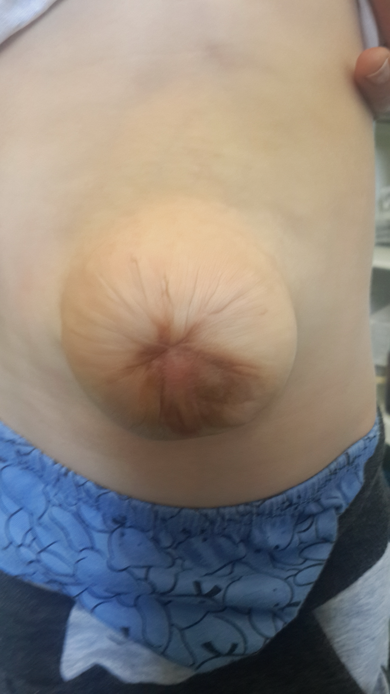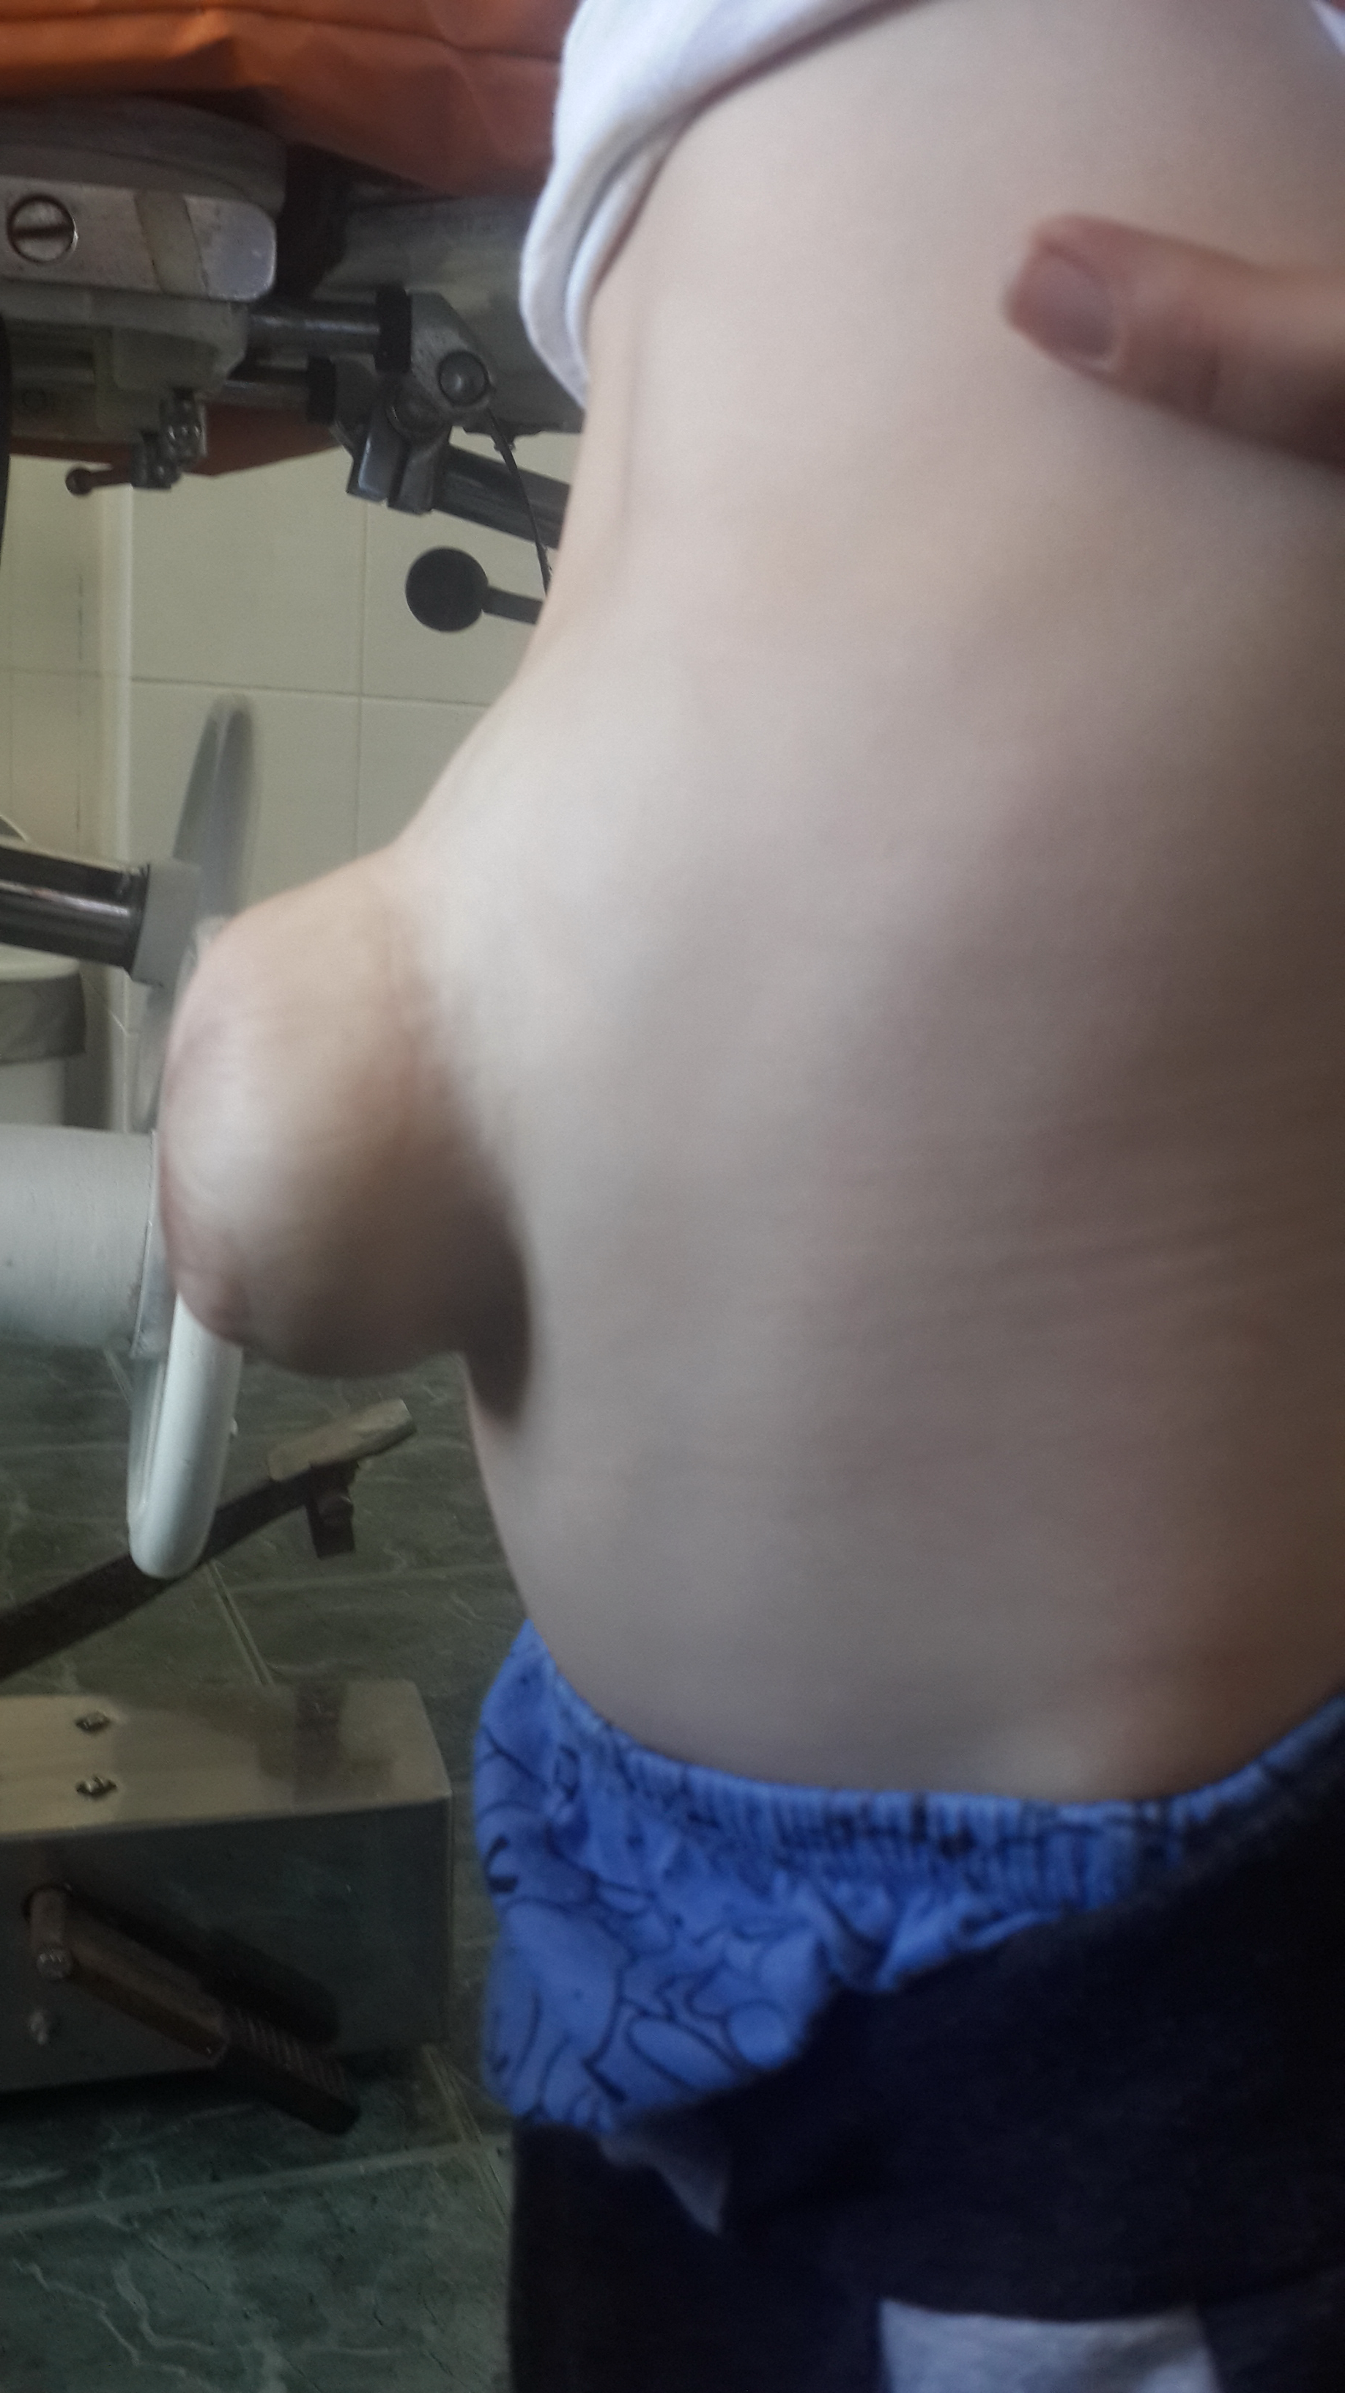
Fig. 13.4. Ventral hernia after skin flaps plasty of omphalocele
Complications
Early post repair complications include surgical site infection, sepsis, dehiscence, ventral hernia, bowel obstruction, bowel perforation, necrotizing enterocolitis, fistulas, renal failure and respiratory distress. Even with successful repair, which usually requires a synthetic patch, and good clinical outcome, the location of the child's liver is central, directly beneath the patch, rendering it more vulnerable to trauma.
Prognosis. Over the past 30 years, the survival rate of babies with gastroschisis and omphalocele has steadily improved, from approximately 60% in the 1960s to more than 90% currently. The observed decline in morbidity and mortality has resulted from improvements in the care of low birth weight and premature babies, particularly those who, because of open abdominal wounds and extruded intestine (gastroschisis).
In children with omphalocele prognosis is dependent upon the severity of the associated problems. Babies with omphalocele are considerably complex, with involvement of many other organ systems. Even giant omphaloceles can be closed, although multiple procedures may be necessary. The limiting factor for many of these babies, however, is their diminutive thoracic cavities and associated pulmonary hypoplasia and resultant chronic respiratory failure. Even so, lung growth and development continue well into childhood, encouraging optimism regarding the ultimate prognosis.
In children with gastroschisis prognosis is dependent mainly upon severity of associated problems, including prematurity, intestinal atresia, short gut, and intestinal inflammatory dysfunction.

Rare abdominal wall defects
In umbilical cord hernias, the umbilical ring is oversized but the amnion is applied normally around the yolk sac and connecting stalk.
Urachal remnants and omphalomesenteric duct malformations result from absent or deficient apoptotic cell death of the epithelium of the urachus and yolk stalk, which, in normal embryogenesis, cause these structures to disappear.
Bladder exstrophy. Abnormal development of the lower body wall results from defective enfolding of the caudal pole of the embryo and deficient incorporation of the yolk sac and allantois; this is associated with malformation of external genitalia. Bladder exstrophy has an incidence of 3.3 in 100,000 births. The bladder develops during the fifth to ninth gestational weeks, and urine mixes with amniotic fluid by the tenth week. Normally, the bladder can be visualized by ultrasound by the end of the first trimester. The bladder mucosa is soft and pliable at birth, but within 48 hours’ exposure, it becomes firm and polypoid and prone to malignant degeneration. Surgical closure is staged and varied, but the goal of reconstruction is voluntary urination with continence and correction of the associated vesicoureteral reflux. Characteristic findings include the following:
• Anterior vagina and rectum, which may be prolapsed
• Epispadias, bifid clitoris or penis and scrotum
• Dorsal chordee
• Poor urinary sphincter control
• Waddling gait due to outward and downward rotation of the anterior pelvic ring and pubic symphysis diastasis
Prune belly (Eagle Barrett) syndrome occurs as a result of increased apoptotic cell death in the body wall placode, which leads to insufficient mesodermal cell deposition. Retention of an abnormally large amount of yolk sac causes attenuation of the abdominal musculature. Muscle fibers are absent and replaced by a thick collagenous aponeurosis. Intercellular conduction of electrical impulses is disturbed, which leads to faulty muscular contractions and ineffective peristalsis.
Characteristics of prune belly syndrome include a thin, flaccid abdominal wall and hypertrophy of the bladder wall with dilation of the bladder, ureters, and renal collecting system, which may be associated with obstruction of the prostate urethra at its junction with the bladder neck. Incidence is 1 in 30,000-50,000 births. Approximately 95% of patients are male. Patients are infertile, since absence of prostate and seminal fluid precludes normal sperm development. Surgical repair includes reconstruction of the urinary collecting systems and the abdominal wall, along with bilateral orchiopexies.
Cloacal exstrophy. Faulty development of the urorectal septum leads to anal agenesis and nondivision of the cloaca. Cloacal exstrophy has an incidence of 1 in 200,000-400,000 births. Chromosomal abnormalities are associated with low-set ears, fetal uropathy leading to oligohydramnios, pulmonary hypoplasia, and compression abnormalities, such as indented thorax, deformed digits, talipes, bowed limbs, and dislocated hips. Characteristic features include the following:
• Bladder exstrophy with a central strip of everted intestine
• Duplicated colon and appendix, or colonic atresia and imperforate anus (agenesis of the hindgut)
• Sacral and neurologic anomalies, such as myelomeningocele, hydromyelia, and diastematomyelia.

Basic literature:
- Saleem Islam. Gastroschisis / In: Fundamentals of Pediatric Surgery, 2nd edition, edited by P.Mattei, Springer, 2017 –P. 569 – 574.
- Amita A. Desai and Corey W. Iqbal. Omphalocele / In: Fundamentals of Pediatric Surgery, 2nd edition, edited by P.Mattei, Springer, 2017 –P. 575 – 581.
- Nicole M. Chandler, Paul D. Danielson. Inguinal Hernia and Hydrocele / In: Fundamentals of Pediatric Surgery, 2nd edition, edited by P.Mattei, Springer, 2017 – P. 725 – 733.
- Pediatric surgery – 7th edition / editor in chief A.G Coran ; associate editors, N.S. Adzick, A.A. Caldamone, T.M. Crummel et al., Philadelphia, 2013 – P. 973-984.
Additional literature
- Ashcraft’s Pediatric Surgery / edited by G. W. Holcomb III, J. P. Murphy, associate editor D. J. Ostlie. — 5th ed. – SAUNDES Elselvier, 2010 – P. 625-650.
- Pediatric surgery. Diagnosis and Management / edited by P. Puri, M. E. Höllwarth Springer-Verlag Berlin Heidelberg, 2009 – P. 619 – 658.
- Pediatric surgery (Color atlas) / edited by P. Puri, M. E. Höllwarth – Springer-Verlag Berlin, 2006 – P. 153-170.
- Pediatric surgery / Robert M. Arensman, Daniel A. Bambini, P. Stephen Almond, 2nd ed., - l Texas, 2009 – P. 359-365.
- Fundamentals of Pediatric Surgery / Edited by Peter Mattei - Springer Science, 2010 – P. 515 – 530.
Additional literature:

Tests for initial level of knowledge, keys for tests:

1.The earliest way to diagnose an anterior abdominal wall defect is:
- by physical exam
- by history
- by fetal ultrasound
- by fetal CT scan.

2. The following are correct regarding omphaloceles except:
- is usually covered by a translucent membrane
- is frequently associated with other congenital malformations
- is lateral to the umbilical stump
- is within the umbilical ring.

3. The following are true about gastroschisis:
- occurs lateral to the umbilical stump
- can be diagnosed antenatally
- at birth often have edematous matted intestinal loops
- all of the above.

4. Treatment of abdominal wall defects includes:
- immediate surgical repair
- pushing the intestines back into the abdominal cavity while still in the delivery room
- provide immediate optimal resuscitation and stabilization first, and then surgery
- always do primary closure in both lesions.

5. Gastroschisis is a malformation of the abdominal wall that
- is commonly associated many different genetic disorders.
- usually occurs to the left of the umbilicus but the umbilicus is intact.
- only involves a few layers of the abdominal wall.
- has no membranous covering.
- allows abdominal contents to herniate through the base of the umbilicus.

6. The incidence of gastroschisis worldwide is about
- 1 per 10,000 live births.
- 2 per 10,000 live births.
- 3 per 10,000 live births.
- 4 per 10,000 live births.
- 5 per 10,000 live births.

- Omphalocele (Exomphalos) is a midline defect
- where the abdominal contents herniate to the right side of the umbilicus.
- that rarely contains the liver, bowel, and stomach.
- that allows abdominal contents to herniate through the base of the umbilicus.
- that has no membrane covering.
- where the abdominal contents herniate to the left side of the umbilicus.

- Gastroschisis is a defect resulting from a vascular compromise of
- the left umbilical vein
- the superior mesenteric artery
- the inferior mesenteric artery
- the splenic artery
- the omphalomesenteric artery

9. The most common associated anomaly(s) seen with gastroschisis is (are)
- prune belly syndrome
- genitourinary tract abnormalities
- congenital heart defects
- intestinal tract complications
- hydrocephalus

10. Associated anomalies seen with gastroschisis include all of the following except
- intestinal tract complications such as malrotation, atresia, and stenosis.
- ischemia of bowel sections due to kinking, and obstruction.
- congenital heart defects
- genitourinary tract abnormalities

Keys for tests
- c
- c
- d
- c
- d
- a
- c
- e
- b
- c

Tests for final level of knowledge

1. Omphalocele can be seen with numerous different chromosome abnormalities including triploidy, which is a fetus with
- 45 chromosomes missing an X
- 47 chromosomes with an extra X
- 47 chromosomes with an extra Y
- 47 chromosomes with an extra number 13
- 69 chromosomes

2. During the development of the embryo, if the caudal fold tissue fails to fuse, it results in
- cloacal extrophy of the bladder
- omphalocele
- gastroschisis
- Pentalogy of Cantrell
- ectopia cordis

3. During the development of the embryo, if the lateral tissue folds fail to fuse, it results in
- cloacal extrophy of the bladder
- omphalocele
- gastroschisis
- Pentalogy of Cantrell
- ectopia cordis

4. Beckwith-Wiedemann syndrome may be associated with all of the following except
- an enlarged liver
- enlarged kidneys
- growth restriction
- omphalocele
- macroglossia

5. The ultrasound findings for gastroschisis may include all of the following except
- multiple echogenic free floating bowel loops near the anterior abdominal wall
- no evidence of a membranous covering or sac
- polyhydramnios
- oligohydramnios
- an umbilical cord that inserts into the mass

6.Factors that can sometimes make it difficult to identify gastroschisis include all of the following except
- the size of the defect
- the fetal size
- the gestational age
- too much amniotic fluid (polyhydramnios)
- the fetal position

7. It is important not to make an incorrect diagnosis of a fetal anomaly between the 8th and 12th week of gestation because
- the fetal liver and spleen are not completely formed yet.
- the embryonic bowel normally protrudes into the base of the umbilical cord during this time period and could mimic an anomaly.
- the amount of amniotic fluid is too low at this point in gestation to make an accurate assessment.
- the fetal stomach bubble is not visible enough to confirm the presence of bowel.
- the umbilical cord at this gestational age looks like bowel on ultrasound imaging.

8. The ultrasound findings for omphalocele include
- a solid appearing, round, echogenic mass adjacent to the anterior abdominal wall
- an umbilical cord that inserts to the right of the mass
- an umbilical cord that inserts to the left of the mass
- no evidence of a membranous covering or sac
- a herniation of abdominal contents to the right of the umbilicus

9.With a diagnosis of gastroschisis,
- the fetus should have follow-up ultrasounds to watch for macrosomia.
- the fetus should have follow-up ultrasounds to watch for oligohydramnios.
- karyotyping (genetic amniocentesis) should always be recommended because most cases of gastroschisis are associated with chromosome abnormalities.
- the patient should deliver by cesarean section
- if the case is an isolated gastroschisis the overall prognosis is very poor with a survival rate of less than 10%.

10. Regarding a potential diagnosis of gastroschisis, one potential concern that may result in some prenatal testing centers offering further genetic testing, such as amniocentesis, is
- the issue that an omphalocele may have ruptured through its membrane covering, mimicking the appearance of a gastroschisis.
- the presence of bowel ischemia due to kinking.
- the presence of oligohydramnios.
- the presence of an elevated maternal serum alpha-fetoprotein.
- the presence of bowel thickening due to prolonged exposure to amniotic fluid.

Tasks for final level of knowledge
Task 1. A 25 year second gravida female was sent for routine antenatal ultrasound at 27 weeks of gestation. Her last pregnancy was normal full term hospital delivery 4 years back with delivery of normal healthy child. She didn’t have any major disease and there was no family history of delivery of abnormal child. Maternal serum AFP was not tested. Her calculated gestational age by ultrasonography was approximately 26 weeks and 2 days. On scanning of abdomen, there was large anterior abdominal wall defect in the midline with herniation of liver and bowel loops through it. The contents were covered with a membrane. Umbilical cord was inserted in the center of the covering membrane.

- What is the diagnosis?
- What additional investigations are needed?
- What is the best place for delivery?
- What is the prognosis?

Answer Key. 1.This is a typical prenatal ultrasound features of an omphalocele.
2. Maternal serum AFP, karyotype analysis by amniocentesis or chorionic villous sampling
3. Infants with an abdominal wall defect should be delivered at a perinatal center, where immediate neonatal and surgical expertise are available.
4. Prognosis depends of additional anomalies.

Task 2. A 31-year-old women was referred for evaluation due to the finding of an omphalocele by routine second trimester screening ultrasound. The pregnancy course had been uncomplicated up to this point, including normal prenatal labs. Serum screening had been declined by the patient. Her obstetric history is significant for three full-term vaginal deliveries without complication. The remainder of her history and the family history is unremarkable. No environmental exposures were elicited.
- What is the plan of next evaluation?
- Is a karyotype indicated in this situation?
Answer Key. 1.Comprehensive evaluation performed at 25-weeks gestation included detailed ultrasound, echocardiography
2.Karyotype is necessary if omphalocele is diagnosed.

Task 3. Comprehensive evaluation of 38 year old pregnant women performed at 25-weeks gestation included detailed ultrasound, echocardiography and ultra rapid fetal MRI. Biometrics were appropriate for gestational age. Ah abdominal wall defect containing liver, gallbladder and bowel was seen. Gender could not be determined as the finding in the ultrasound image distorted the visualization between the fetal legs. The pubic bones were splayed and no bladder could be identified. Further imaging of the fetal spine was seen in the MRI demonstrating a neural tube defect. The left kidney could not be visualized and amniotic fluid was normal. A two-vessel umbilical cord was noted. Fetal echocardiogram was normal.

1.Based on the constellation of findings, what is the likely diagnosis?
2.What is the significance of the ultrasound finding?
3.What are associated anomalies seen with this disorder?

Answer Key. 1. Large omphalocele, exstrophy of the cloaca, imperforate anus and spinal defects.
2.The finding is the classic appearance of the “elephant’s trunk” in which the terminal ileum prolapses through the cecum and is often seen between the fetal legs. This can also further obscure gender determination.
3.Single umbilical artery, limb defects (arthrogryposis, club feet, syndactyly), cardiac, gastrointestinal (atresia, malrotation, bowel duplication), neurologic (hydrocephalus) and urogenital (renal agenesis, ectopic kidney, duplicated collecting system, ambiguous genitalia, abnormal scrotum, uterine abnormalities) anomalies have been described.

