- An 17-year-old male comes to the physician's office because of dull aching and fullness of the scrotum. Examination shows soft left-sided scrotal swelling; transillumination testing is negative. The scrotal swelling increases when the patient performs the Valsalva maneuver. The physical examination is otherwise

A. Hypoalbuminemia
B. Dilatation of pampiniform plexus
- Fluid in the tunica vaginalis
- Testicular neoplasia
- Cystic dilations of the efferent ductules

Explanation: The patient described has a varicocele. A varicocele is a tortuous dilation of the pampiniform plexus of veins surrounding the spermatic cord and testis in the scrotum. A varicocele results from incompetence of the valves of the testicular vein and occurs most frequently on the left side, possibly because the left testicular vein enters the left renal vein interiorly at a right angle thereby predisposing to impaired drainage. Patients are commonly asymptomatic. Those who do complain of symptoms may endorse a "dull" or "dragging" discomfort of the scrotum that is worse when standing. On examination, the affected side of the scrotum will feel similar to a "bag of worms" and the Valsalva maneuver will typically cause the mass to enlarge.
(Choice A) Hypoalbuminemia may cause edema leading to fluid accumulation in dependent areas such as the legs and scrotum.
(Choice C) Fluid in the tunica vaginalis is the cause of a hydrocele. Typically, a hydrocele will transilluminate on physical examination. Communicating hydroceles are frequently reducible but may also increase in size with the Valsalva maneuver.
(Choice D) Testicular neoplasia typically presents as a painless testicular mass though aching or acute pain may also occur. Examination typically discloses a firm, nontender mass that does not transilluminate.
(Choice E) Cystic dilations of the efferent ductules (spermatocele) are painless fluid-filled cysts that contain sperm. They are located on the superior pole of the testis in relation to the epididymis. These masses are distinct from the testis and classically transilluminate.

Educational objective:
Patients with varicocele classically present complaining of dull, aching pain in the testis. Varicocele is most common on the left side. It results from a swelling of the pampiniform plexus of veins and feels like a "bag of worms" on exam.
- A one-year-old boy is brought to the emergency department with scalds on both the buttocks and thighs. His mother states that the child was burned because she accidentally drew a bath for the child with water that was too hot. She states the injury occurred 2 days ago. On examination, the child is irritable. Second-degree burns are noted on the buttocks, genitalia, waist, proximal thighs and feet. There is an abrupt demarcation between the burned and unaffected skin. A faint yellow patch of discoloration is noted on the left thorax with a slight violaceous hue. The child has not yet had his 1-year vaccinations. Which of the following is the most appropriate next step in management?

A. Give wound care instructions and send the patient home with analgesics
B. Admit the patient and do a skeletal survey
C. Give wound care instructions and advise the mother that she should keep the temperature of the water heater below 140 F to avoid such injuries in future
D. Ask the mother if the child is being abused
E. Advise the mother of the suspected abuse, but do not notify authorities because this is a violation of patient confidentiality

Over 1% of children in the United States are victims of child maltreatment, which can take on many forms including physical or sexual abuse, psychological abuse, neglect or Munchausen disease by proxy. Most cases of child abuse that present for medical evaluation will enter the medical system via the emergency department. Emergency physicians must maintain a high index of suspicion for abuse. To reinforce the need for reporting, many local authorities have implemented policies including fines or imprisonment for failing to report suspected abuse to child protective services. Factors that may indicate child abuse include but are not limited to the following:
- Patterned scalds and burns indicative of forceful immersion or the use of a hot object such as a cigarette or curling iron
- Incoherent or improbable explanation of the injuries
- Delay in seeking care after the injury
- Fractures of the long bones or ribs, fractures in various stages of healing
- Bruising on areas other than those overlying bony prominences
- Suspicious bruises include those on the thighs, abdomen, cheeks and genitalia
- Patterned bruising such as loops from a cord or belt or imprints of a hand
- Subdural hematoma and retinal hemorrhages in very young infants
9. Inappropriate affect of the caregiver
In any case of suspected child abuse, the physician should do the following;
- Perform a thorough physical examination and obtain a radiographic skeletal survey in order to identify and document any signs of abuse.
- Report the case to child protective services
- Admit the patient to ensure their safety
In the case described, the wounds are most consistent with an intentional immersion burn. These burns classically show a sharp demarcation between the burned and unburned skin and sparing of the bilateral gluteal regions because these are typically firmly pressed against the bottom of the tub thereby preventing burning. Additionally, the mother's story is inconsistent with the injuries and she has delayed seeking medical care for 2 days.
(Choices A & C) The child should never be sent home in cases of suspected child abuse. It is mandatory to report the case to child protective services and hold the patient in the hospital. Maintaining the water temperature below 140° F helps prevents scalds in most of the cases.
(Choice D) The caregiver should never be confronted in case of suspected child abuse. They should simply be informed that abuse is suspected and will be investigated by the appropriate authorities. Accusations should not be made by the physician.
(Choice E) Physicians are mandatory reporters for suspected child abuse. It is illegal to not report such incidents.

Educational objective:
In cases of suspected child abuse, physicians are required to thoroughly examine the child for documentation of all potential signs of abuse. This includes a complete skeletal survey. Child protective services should be notified of all suspected cases immediately, and the patient should be admitted

- A 16-year-old boy was brought to the emergency department because of left shoulder and left hand pain after falling on his outstretched hand while playing soccer. He heard a crunching sound and had intense pain in his left shoulder area following the injury. Examination shows bruising around the clavicle area. He is holding his left arm with his right hand. There is a palpable gap in the middle of the clavicle. Auscultation shows a loud bruit just beneath the clavicle. An x-ray film of the left shoulder and chest shows the middle of the clavicle is fractured and displaced. Which of the following is the most appropriate next step in management?

- CT chest for pneumothorax
- Nerve conduction studies
C. Angiogram
D. Open reduction of the clavicle
E. Closed reduction with figure of eight brace

Explanation:
The clavicle is one of the most commonly injured bones in the body. The majority of clavicular fractures occur in the middle third of the bone. Injury to this bone classically occurs during athletic events and follows a fall on an outstretched arm or a direct blow to the shoulder. Patients with clavicular fractures present with pain and immobility of the affected arm. The contralateral hand is classically used to support the weight of the affected arm. The shoulder on the affected side is displaced interiorly and posteriorly. A careful neurovascular exam should accompany all fractures to the clavicle due to its proximity to the subclavian artery and brachial plexus. In this case, a bruit is heard and an angiogram is necessary to rule out injury to the underlying vessel.
(Choice A) The patient already has had a chest x-ray, which is sufficient to make the diagnosis of a clinically relevant pneumothorax.
(Choice B) A clavicle fracture may rarely injure the brachial plexus. While brachial plexus injury may be assessed with nerve conduction studies, clinical examination of motor function of the hand and arm is sufficient.
(Choices D and E) Fractures of the middle third of the clavicle, which account for most clavicular fractures, are treated nonoperatively with a brace, rest and ice. Fractures of the distal third of the clavicle may require open reduction and internal fixation to prevent nonunion. In cases managed nonoperatively, early range of motion and strengthening are recommended to prevent loss of motion at the shoulder.
Educational objective:
All patients with a clavicular fracture should have a careful neurovascular examination to rule out injury to the underlying brachial plexus and subclavian artery.

- A 12-year-old boy is brought to the emergency department after falling from a tree. Examination shows tenderness and swelling over the left lower arm. An x-ray film of the arm shows a fracture of the distal end of the humerus with proximal and posterior displacement of the distal fracture segment. Closed reduction of the fracture is performed. However, postoperatively the patient complains of increasing pain in the left arm and forearm. Twelve hours postoperatively his forearm is pale and cold. There is marked pain on passive extension of the fingers. Which of the following is the potential dreaded complication of this condition?
- Malunion with alteration of carrying angle
- Non-union
- Reflex sympathetic dystrophy
- Sudeck's atrophy
E. Volkmann ischemic contracture

Explanation:
This patient is experiencing acute compartment syndrome secondary to supracondylar fracture of humerus. Supracondylar fracture of humerus is common in young children and adolescents secondary to fall on an outstretched hand. Compartment syndrome results from increased pressure within a limited anatomic space, acutely compromising the circulation and ultimately threatening the function of the tissue within that space. Diagnosis of compartment syndrome is made predominantly on clinical findings of pain, pallor, pulselessness, paralysis and paresthesia. Treatment consists of immediate fasciotomy.
Volkmann's ischemic contracture is the final sequel of compartment syndrome in which the dead muscle has been replaced with fibrous tissue (Choice E).
(Choice A) Malunion with alteration of carrying angle is another common complication of supracondylar fracture of humerus; however it is not a sequel of compartment syndrome.
(Choice B) Non-union is not a common complication of supracondylar fracture of humerus and does not occur as a sequel of acute compartment syndrome.
(Choice C and D) Reflex sympathetic dystrophy is a vague painful condition seen as a sequel of infection or trauma which may be minor. It is characterized by pain, hyperesthesia and tenderness, which are out of proportion to the physical findings. It does not have an acute onset like in this patient and is not associated with compartment syndrome. Sudeck's atrophy is a radiographic term for spotty rarefaction seen in patients with reflex sympathetic dystrophy.
Educational objective:
Volkmann's ischemic contracture is the final sequel of compartment syndrome in which the dead muscle has been replaced with fibrous tissue.

- A 16-year-old boy is brought to the emergency department after falling off a bicycle and hitting his head on the ground. He briefly lost consciousness but had no seizures. He had two episodes of vomiting and complains of mild headache. His mother accompanies him and demands immediate evaluation. He has no other medical problems. His blood pressure is 121/67 mm Hg and pulse is 78/min. Examination shows a small bruise on his forehead but no bony abnormalities. The rest of the physical examination, including neurologic examination, shows no other abnormalities. Which of the following is the most appropriate next step in management?

- Admit the patient and observe for neurologic signs every 2 hours for a total of 6-8 hours
- Admit the patient, order a CT scan of the head, and observe for neurologic signs every 2 hours
- Discharge the patient home and ask him to return if he develops any new symptoms
- Discharge the patient home if a skull radiograph is normal and ask him to return if he develops any new symptoms
- Discharge the patient home if a CT scan of the head is normal and ask him to return if he develops any new symptoms

Explanation:
This patient presents after a traumatic fall with loss of consciousness, headache, and vomiting consistent with an acute head injury. Most head injuries are mild and will not progress to more serious clinical scenarios. Minor head trauma is defined as a head injury that is associated with a Glasgow coma scale (GCS) score of 15, normal mental status on examination, no abnormal neurologic or funduscopic examination findings, and no physical evidence of skull fracture. These patients can be discharged with no further imaging or studies if a reliable individual can monitor them for 24 hours following the injury (Choice C).
Mild traumatic brain injury (TBI) is defined as a head injury that is associated with a GCS score of 13-15 and brief loss of consciousness, vomiting, headache, or disorientation. Patients with moderate TBI have a GCS score of 9-12, and those with severe TBI have a GCS score of <8. Patients with severe TBI, evidence of intracranial injury, focal neurologic signs, seizure, prolonged loss of consciousness, and evident skull fracture on examination should have a CT scan of the brain and be observed in the hospital with frequent neurologic examinations (Choices A and B)

Patients with mild-to-moderate TBI who have vomiting, headache, or brief loss of consciousness (such as this patient) should also have a CT scan of the head. If the CT scan is normal, these patients can be discharged with a reliable caretaker and printed instructions (with a list of symptoms) that describe when they should return to the hospital. Patients with mild-to-moderate TBI who do not have any of the above symptoms do not need neuroimaging and can be observed for 4-6 hours in the emergency department, with neuroimaging reserved for those who worsen.

(Choice D) Head CT scans are superior to skull radiographs for assessing head injury and detecting skull fractures, hemorrhage, hematoma, and displacement of the midline structures in the head.

Educational objective:
Patients with mild-to-moderate traumatic brain injury can be discharged under the care of an adult if they have a normal CT scan. The caretaker should be given printed instructions detailing the signs and symptoms that warrant immediate return to the hospital.

- A 12-year-old boy is brought to the physician because of right groin pain, knee pain, and limping. He has had these symptoms for the past 2 weeks. He is at the 90th percentile for weight and 60th percentile for height.
He is afebrile, and his other vital signs are within normal limits. Examination shows that the range of motion of the right knee joint is within normal limits but hip movements are restricted and the right foot points outward. There is external rotation of the right thigh on flexion of the hip. After confirming the diagnosis, which of the following is the most appropriate management?

A. Aspiration and microscopic examination of the hip joint synovial fluid
B. Closed reduction of the hip joint
C. Conservative management with rest and analgesics
D. Immediate osteotomy of the femoral neck
E. Surgical pinning of the femoral head

This patient has a slipped capital femoral epiphysis (SCFE), which is characterized by displacement of the femoral head on the femoral neck due to disruption of the proximal femoral growth plate. It is commonly seen in obese adolescent boys. The physis (i.e., physical junction between the femoral head and neck) weakens during early adolescence because it is rapidly expanding and primarily composed of cartilage, which does not possess the strength of bone. When exposed to excessive shear stress, which is magnified by obesity, the physis fractures and the femoral head slips posteriorly and medially relative to the femoral neck.
Patients typically present with hip or knee pain of insidious onset that causes limping. Acute presentations can occur. Diagnosis requires a high degree of clinical suspicion because knee pain (referred pain), not hip pain, is a common presenting complaint with this condition. Physical examination shows loss of abduction and internal rotation of the hip as well as external rotation of the thigh while the hip is being flexed. A frog-leg, lateral-view x-ray of the hip is the diagnostic imaging technique of choice.
Patients with SCFE should be promptly treated with surgical pinning of the slipped epiphysis where it lies (i.e., in situ) in order to lessen the risks of avascular necrosis of the femoral head and chondrolysis.
(Choice A) Joint aspiration and microscopic analysis are useful in the diagnosis of a septic joint or crystal-induced arthropathy.
(Choice B) Closed reduction is not advised due to the risk of further damage to the tenuous blood supply of the femoral head, which can lead to avascular necrosis.
(Choice C) Conservative management with rest and analgesics is indicated in the treatment of a tendinous or ligamentous strain.
(Choice D) Corrective osteotomies can cause avascular necrosis and might not correct the exact anatomic deformity. They are usually undertaken later in treatment if a patient experiences persistent pain and limited range of motion after initial repair and attempted rehabilitation.

Educational objective:
Slipped capital femoral epiphysis typically occurs in obese, early-adolescent boys. It should be promptly treated with surgical pinning of the slipped epiphysis where it lies (i.e., in situ) in order to lessen the risks of avascular necrosis of the femoral head and chondrolysis.

- A 3-year-old girl is brought to the emergency department because she is not moving her right arm. Her mother states that the child was perfectly normal in the morning. She remembers that she lifted the child with the child's right forearm and since then she has not been moving her right arm. Examination shows the right arm is held in pronation against the chest. The child avoids any movement of her right arm. Which of the following is the most appropriate next step in management?

A. Refer the child to an orthopedic surgeon for possible supracondylar fracture of humerus
B. Report the case to child protection agency
C. Gentle passive elbow flexion and forearm supination
D. Closed reduction and casting of forearm and arm
E. Do a skeletal survey of the child

Explanation:
Nursemaid elbow is a common injury among preschool children. It refers to subluxation of head of radius at elbow joint. The injury can occur innocently from swinging a young child by the arms or pulling a child's arm while in a hurry. The child is usually not in distress at presentation but would cry at any attempt to flex the elbow or supinate the forearm. Diagnosis is made clinically as radiographs are often normal.
Treatment of this condition is closed reduction (Choice C) in following steps:
• First extend and distract the elbow.
• Next supinate the forearm.
• Hyper flex the elbow with your thumb over the radial head in order to feel the reduction as it occurs.
No post reduction films are needed, since success is usually demonstrated by the infant who has resumed the use of previously unused extremity.
(Choice A and D) are not needed, as this is a temporary condition without permanent effect.
(Choice B and E) are not needed, as subluxation of radial head is a very common injury in preschool children, which is most commonly accidental. Also, the clinical presentation of this patient is not suggestive of any child abuse.

- A 12-year-old boy comes to the emergency department complaining of vague left-sided chest discomfort.
Two months ago, he was involved in a high-speed motor vehicle accident but sustained only minor injuries. He was observed in the emergency department overnight and discharged home. His past medical history is otherwise unremarkable. Vital signs are normal. Auscultation of the lungs shows decreased air entry into the left lower base. An x-ray of the chest is shown below.
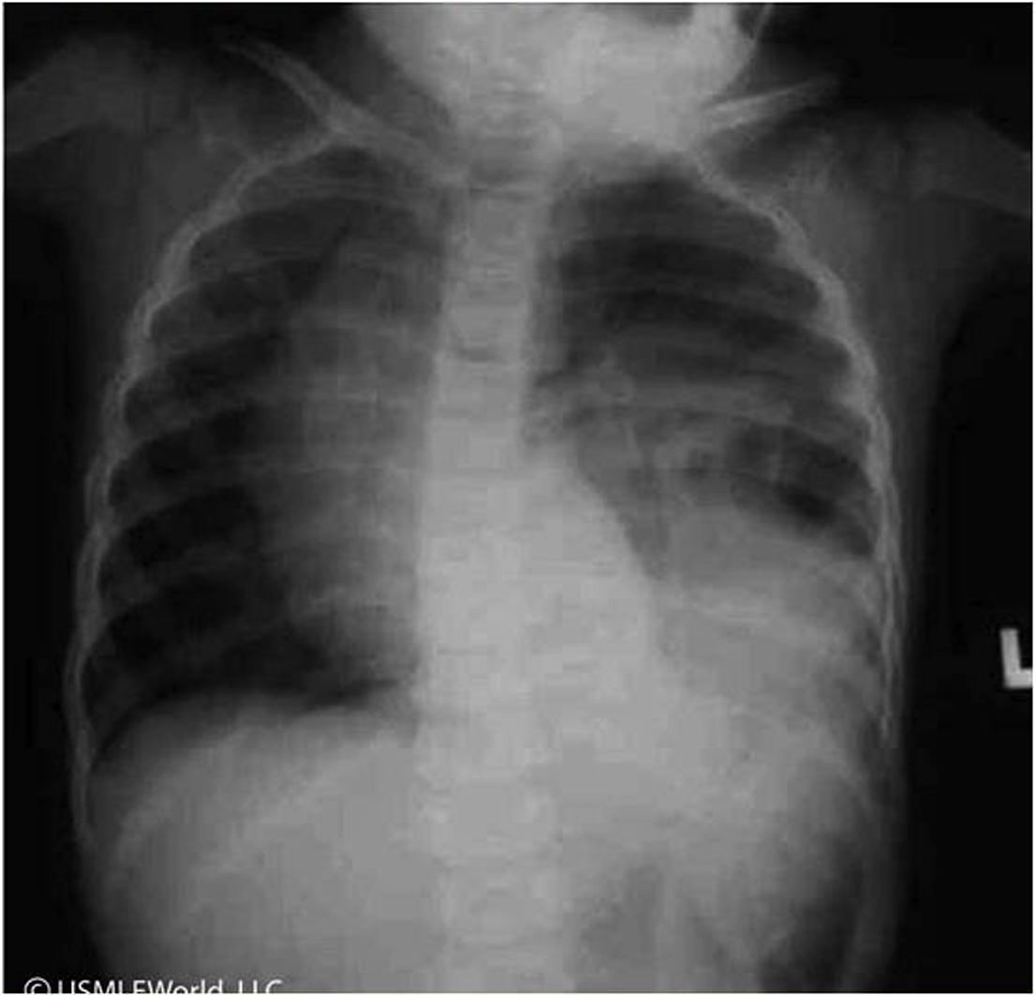

Which of the following is the most appropriate next step in management of this patient?
A. Chest tube placement
B. Computed tomography scan of the chest and abdomen
C. Flexible bronchoscopy
D. Intravenous antibiotics
E. Reassurance and outpatient follow-up
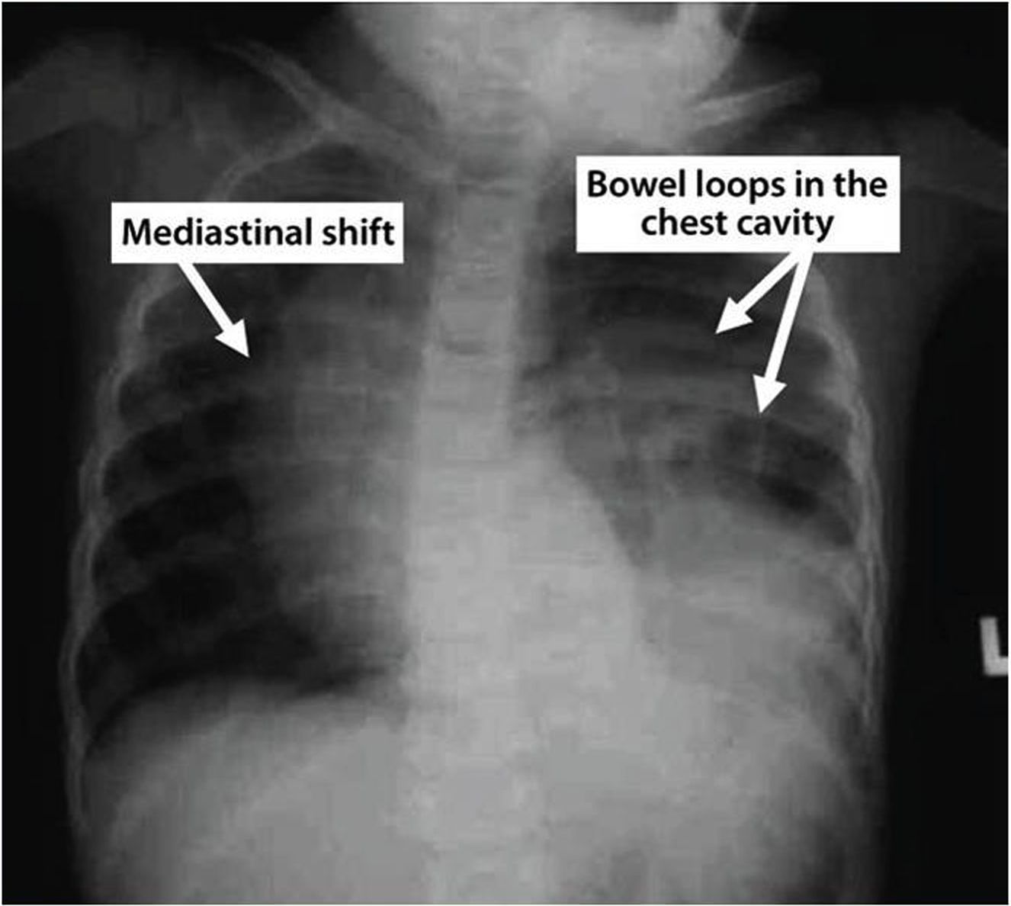
Blunt abdominal trauma due to motor vehicle accident can significantly raise intra-abdominal pressures and lead to diaphragmatic rupture or avulsion from its attachments. The left diaphragm is more prone to injury than the right due to congenital weakness in the diaphragm's left posterolateral region and the liver's protective effects on the right side. Some patients (especially children) with traumatic diaphragmatic injury may initially have no symptoms or signs and can have a delayed presentation (months to years) with expansion of the diaphragmatic defect and herniation of abdominal organs. This delayed diagnosis is associated with a high morbidity and mortality and can increase the risk of hernia formation and strangulation (Choice E).
This patient's chest x-ray shows bowel loops within the thoracic cavity (seen as left lower lung opacity with obscure left hemidiaphragm) and shifting of the mediastinum to the right. Although these findings suggest diaphragmatic injury, computed tomography (CT) scan of the chest and abdomen is more sensitive and is the definitive diagnostic modality.
(Choice A) Chest tube insertion is appropriate for patients with large traumatic pleural effusion (hemothorax) or pneumothorax. This patient's x-ray findings are more suggestive of bowel loops in the chest cavity and require CT scan to confirm diaphragmatic injury.
(Choice C) Flexible bronchoscopy can visualize the proximal airway lumen and mucosa to assess airway patency. It can also evaluate airway masses and help biopsy the mediastinal lymph nodes. However, this patient's absence of obstructive symptoms and x-ray findings make the need for flexible bronchoscopy less likely.
(Choice D) Intravenous antibiotics would be required if chest x-ray showed evidence of pneumonia (seen as infiltrates). However, this patient's x-ray does not suggest pneumonia.

- An overweight 12-year-old boy presents with left knee pain that has been going on intermittently for the past three months. Physical activity, especially stair climbing, exacerbates the pain. The boy's mother also points out that he has been limping recently. On physical examination, his anterior left hip is moderately tender to palpation, and when he is asked to stand on his left leg, the right half of his pelvis tilts downward. Which of the following best explains this finding?

A. Tensor fascia lata weakness
B. Psoas muscle weakness
C. Quadratus lumborum weakness
D. Quadriceps muscle weakness
E. Gluteus muscle weakness

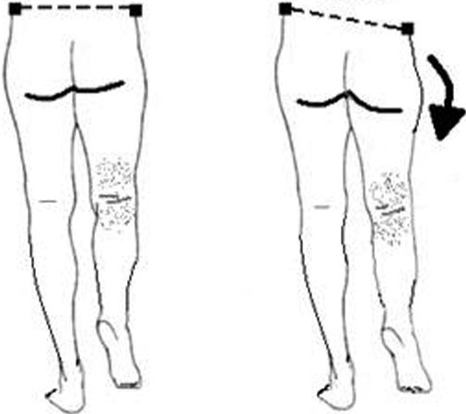
The physical exam finding described is the Trendelenburg sign, a drooping of the contralateral pelvis that occurs when the patient stands on one foot. The associated Trendelenburg gait is waddling in quality, caused by the trunk's rocking to compensate for this pelvic drooping during the stance phase of gait.
Normally, the gluteus medius and gluteus minimus muscles, which are both innervated by the superior gluteal nerve, function to abduct the thigh at the hip when standing on one foot or during normal ambulation when the body's weight rests on only one foot. Weakness of these muscles, as can occur in neuromuscular disease, impingement of or trauma to the superior gluteal nerve, or inflammatory myopathies, results in a positive Trendelenburg sign and gait.
(Choice A) The tensor fascia lata spans from the iliac crest to the fascia lata. It is a small muscle that assists in hip abduction and maintenance of knee extension.
(Choice B) The psoas major muscle spans from the transverse processes of the lumbar vertebrae to the lesser trochanter of the femur. It functions to flex and laterally rotate the thigh.
(Choice C) The quadratus lumborum spans from the iliac crest to the 12th rib and the transverse processes of the first four lumbar vertebrae. It functions in rib cage fixation and in lateral flexion of the trunk.
(Choice D) The quadriceps femoris muscles all function in leg extension at the knee. The rectus femoris also functions as a hip flexor.

Educational objective:
Drooping of the contralateral hemipelvis below its normal horizontal level during monopedal stance constitutes a positive Trendelenburg sign. It is caused by weakness or paralysis of the gluteus medius and minimus muscles, which are innervated by the superior gluteal nerve.

- A 12-year-old boy is brought to the emergency department after being involved in a motor vehicle collision. He is in no distress and is admitted for observation. Two hours after admission, he develops tachypnea and tachycardia. His temperature is 36.7° C (98° F), blood pressure is 110/66 mm Hg, pulse is 110/min, and respirations are 22/min. Examination shows bruises on the right side of the chest, but palpation of the ribs does not elicit pain or suspicion for rib fractures. Breath sounds are decreased on the right side. ABG on 6 liters of oxygen shows: P02 of 60 mm Hg, PC02 of 32 mm Hg, and pH of 7.42. An x-ray film of the chest shows a patchy irregular alveolar infiltrate in the right middle and lower lobes. Which of the following is the most likely diagnosis?

A. Adult respiratory distress syndrome
B. Aspiration pneumonia
C. Fat embolism
D. Hemothorax
E. Pulmonary contusion
F. Pneumothorax
G. Cardiac contusion
H. Flail chest

Explanation:
Pulmonary contusion represents parenchymal bruising of the lung, which may or may not be associated with rib fractures. The clinical manifestations develop usually in the first 24 hours (often with in few minutes); tachypnea, tachycardia, and hypoxia are characteristic. Physical examination typically reveals chest wall bruising and decreased breath sounds on the side of pulmonary contusion. Chest x-ray reveals patchy irregular alveolar infiltrate and a CT scan may be employed to make an early diagnosis. ABG typically shows hypoxemia and, itself, is an indication to suspect pulmonary contusion in trauma patients.
This is very important to differentiate pulmonary contusion from adult respiratory distress syndrome (ARDS) (Choice A). ARDS usually manifests 24-48 hours from the trauma; besides that, bilateral lung involvement is present.

(Choice B) Pulmonary aspiration may be unilateral or bilateral and fever and inflammatory reaction are characteristic.
(Choice C) Fat embolism occurs after long bone fractures. The clinical picture includes tachypnea, tachycardia, hypotension, mental changes, thrombocytopenia, and petechiae.
(Choice D) Hemothorax is detected on chest radiograph as pleural effusion and, if significant, hypotension is present.

Educational Objective:
Pulmonary contusion is not uncommon after high-speed car accidents. The symptoms usually develop in the first 24 hours and a patchy alveolar infiltrate on chest x-ray is typical.

- A newborn infant is found to have a scrotal mass. The mass is cystic and transilluminated with light. He is born without any other complications. The vital signs are within normal limits. Other physical examination is unremarkable. Which of the following is the most appropriate next step in management?

A. Aspiration of fluid
B. Surgical intervention
C. Ultrasound examination
D. Reassurance and observation
E. Check 24-hour urinary protein excretion

Explanation:
The patient described most likely has a hydrocele. A hydrocele is a fluid collection within the processus or tunica vaginalis - the peritoneal projection that accompanies the testis during its descent into the scrotum. When the processus vaginalis fails to obliterate, peritoneal fluid may accumulate within the processus vaginalis causing a communicating hydrocele. A collection of fluid within a tunica vaginalis that has properly obliterated its communication with the peritoneum is a noncommunicating hydrocele. Hydrocele can be differentiated from other testicular masses by transillumination; a hydrocele will transilluminate while other masses will not. Most hydroceles, both communicating and noncommunicating, will resolve spontaneously by the age of 12 months and can be safely observed during that period.
(Choice A) Risks of aspiration include the potential for infection and damage to nearby structures. It is not reasonable to put the patient at risk for a lesion that will likely resolve spontaneously.
(Choice B) Communicating hydroceles that persist beyond 12 months of age are unlikely to resolve spontaneously and put the patient at increased risk of indirect inguinal hernia. Surgical intervention is indicated in such cases.
(Choice C) Ultrasound imaging of the mass described is not unreasonable but is not required as the diagnosis is apparent by physical exam.
(Choice E) Nephrotic syndrome generally causes generalized edema. It is very unlikely in this patient.

Educational Objective:
Most cases of hydrocele will disappear spontaneously by the age of 12 months and can be safely observed during that period. Hydroceles that do not resolve spontaneously should be removed surgically due to the risk of inguinal hernia.

- A 7-year-old boy has been complaining of left hip pain for the past 8 months. Over recent weeks, he has developed a limp. When you examine his gait, you note that he takes short steps with his left leg. On physical examination, his left hip has significantly limited range of motion, and there is atrophy of the left proximal thigh muscle. X-ray of the patient's pelvis is shown below:

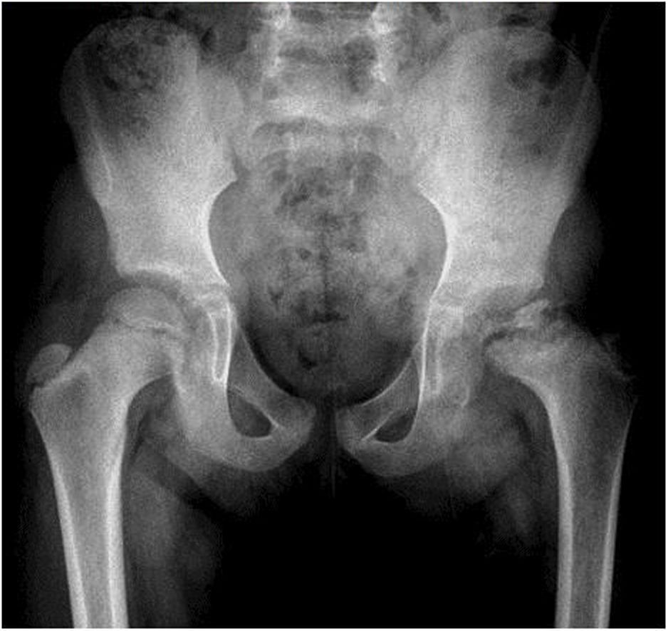

Which of the following is most likely responsible for this patient's condition?

A. Slipped epiphysis
B. Bone infection
C. Osteonecrosis
D. Muscle dystrophy
E. Synovitis
F. Malignancy

Explanation:
These clinical and radiographic findings are characteristic of idiopathic avascular necrosis of the femoral capital epiphysis, or Legg-Calve-Perthes disease. This condition most commonly affects boys between ages 4 and 10, with a peak incidence between 5 and 7. The classic presentation is hip, groin or knee pain plus
These clinical and radiographic findings are characteristic of idiopathic avascular necrosis of the femoral capital epiphysis, or Legg-Calve-Perthes disease. This condition most commonly affects boys between ages 4 and 10, with a peak incidence between 5 and 7. The classic presentation is hip, groin or knee pain plus an antalgic gait. In general, these patients are managed conservatively with observation and bracing, though surgery may be indicated in cases where the femoral head is not well contained within the acetabulum.
(Choice A) In slipped capital femoral epiphysis (SCFE), the metaphysis and proximal femur slip relative to the epiphysis at the epiphyseal plate. The capital femoral epiphysis remains structurally intact within the acetabulum. The classic presentation is an obese adolescent male with complaints of pain.
(Choice B) In pediatric patients, the most common etiology of osteomyelitis is hematogenous seeding by 5. aureus. The infection tends to affect the metaphysis, with epiphyseal sparing. Radiographic evidence of osteomyelitis is subtle early in the course of the disease.
(Choice D) Duchenne muscular dystrophy, the most common childhood myopathy, causes proximal muscle weakness and calf pseudohypertrophy. The disease progresses to complete immobility by early adolescence. Joint radiographs are usually normal.
(Choice E) Transient synovitis of the hip is a common cause of limp in otherwise healthy children. There are no associated radiographic abnormalities.
(Choice F) Osteosarcoma is a primary bone cancer that produces a finding called Codman's triangle in the metaphyses of long bones. Ewing sarcoma is a primary bone cancer that causes similar radiographic findings, but which tend to affect the diaphyses of long bones.

13. An 17-year-old man is brought to the emergency department after sustaining a fall from a three-story building. He landed on his right leg and heard a snap. He felt excruciating pain in his thigh and noticed that it appears deformed. His past medical history is unremarkable, and he does not receive any medications. On physical examination, his blood pressure is 152/78 mm Hg and pulse is 95/min. His head, neck, cardiovascular, pulmonary, and abdominal examinations are unremarkable. There is extreme tenderness to movement and palpation of the right thigh. There is marked swelling over the region. The compartmental pressure of the right thigh is 15 mm Hg. His popliteal and pedal pulses on the right are barely palpable. His corresponding left-sided pulses are 2+ A radiograph film shows a comminuted fracture through the right femoral diaphysis with lateral angulation. Laboratory values are:
White blood cells 6,700/mm 3
Hematocrit 42%
Platelets 289,000/mm3
INR 1.0
Partial thromboplastin time 20 seconds
Which of the following is the next step in the management of this patient?

A. CT angiography of the right leg
B. Emergent fasciotomy
C. Reduction of the fracture
D. Right-leg amputation
E. Vigorous hydration

The correct answer is A. He does not have normal pulses beyond the injury, and the integrity of his arterial tree needs to be assessed. Vascular injury can be a sequela of femoral fractures, posterior knee dislocation, or fracture of the proximal tibia and fibula. A noninvasive CT angiography would be a good way to start the evaluation.
An emergent fasciotomy (choice B) should be used in acute compartment syndrome; the compartment pressure should be greater than 30-40 mm Hg.
Reduction of the fracture (choice C) can be performed, if the procedure is necessary, after vascular integrity has been assessed. Fixation of the fracture should be done first, along with fluid resuscitation and blood transfusion, if the fracture bleeds into the tissues sufficiently to cause hypovolemic shock.
Right-leg amputation (choice D) is unnecessary at this time, as the leg may be salvaged with an intervention after the vascular damage has been assessed.
Vigorous hydration (choice E) would be necessary in the case of hypovolemia, which is not the case here.
• Fractures can lead to vascular injury.
• Diminished or absent pulse in the presence of normal compartment pressure indicates arterial injury.

- A patient who is in shock and has multiple traumatic injuries is taken to the operating room for an exploratory laparotomy that lasts 3.5 hours. Multiple blood transfusions are administered, and several liters of Ringer's lactate are infused during surgery. At the second postoperative day, the patient develops confusion, agitation, lower extremity edema and cyanosis, and abdominal distension. The abdominal sutures are cutting through the skin around them. The patient’s creatinine level has doubled since the surgery. Which of the following treatments at the time of the initial surgical intervention could have prevented these complications?

A. Approximate the skin only, using towel clips
B. Close the abdomen with heavy retention sutures
C. Give diuretics and close the abdomen in the usual way
D. Leave the abdomen and its contents open to air
E. Provide temporary abdominal closure with an absorbable mesh
F. Use absorbable sutures only

The correct answer is E. This patient has abdominal compartment syndrome. The massive infusion of Ringer's lactate, although lifesaving, produces severe edema in the surgical field. Forced closure will increase intra-abdominal pressure, which will compress the lungs (and thus produce hypoxia) and compress the inferior vena cava (and thus cause renal failure). Distension of the skin will cause the sutures to cut through the skin around them. To avoid this set of complications, a temporary abdominal closure or absorbable mesh can be left in place at the time of surgery to protect the bowel without undue pressure. Abdominal compartment syndrome can be clinically confirmed by measuring bladder pressures. Pressure >30 mm Hg indicates significantly compromised venous return and should be released with the aid of a temporary abdominal closure. Closing the skin only (choice A) can be lifesaving when hypothermia develops during surgery. In this setting, however, the skin will not come together without undue tension.
Forced closure (choice B) would compromise ventilation and produce acute renal failure caused by pressure on the inferior vena cava.
Diuretics (choice C) cannot selectively remove the fluid from the swollen tissues.
Leaving the bowel exposed to the air (choice D) is not an option. In the short-term, the patient will suffer severe heat loss; later, the bowel will dry out, perforate, or fistualize.
Absorbable sutures (choice F) provide no advantage here; they will exert the same undesired tension as the regular sutures.
In the multiple trauma setting, lifesaving massive fluid infusion may produce severe edema of the abdominal contents. Forced closure will increase the intra-abdominal pressure, compressing the lungs and the inferior vena cava, and the distension of the skin sutures will produce cuts in the skin around them. This is known as abdominal compartment syndrome. To avoid this set of complications, a temporary plastic coverage or absorbable mesh should be placed at the time of the surgery to allow closure of the wound.

- A 12-year-old boy is brought to the office complaining of recurrent knee pain. His mother reports that for the last 12 to 18 months, when he comes home from school he refuses to exert himself in anyway because his knees hurt from physical education class at school. At first she believed he was simply being lazy, but finally decided to have him examined. On examination, the boy is in the fiftieth percentile of

height and the seventy-fifth percentile of weight. He appears to be well and in no apparent distress. No significant motor or sensory deficits are noted in the lower extremities, and all deep tendon reflexes are intact. Range of motion at all joints is within normal limits; however, on flexion of the knee joints he complains of pain in his proximal shin, and he is tender to palpation over the tibial tubercle. What is the most appropriate management of this condition?

A, Excision of the tibial tubercle
B. Immobilization with a hard cast
C, Intra-articular steroid injection
D. Regular use of nonsteroidal anti-inflammatory drugs
E. Rest and ice after physical activity
F. Rest, ice, and crutches for 6 weeks

The correct answer is E. The diagnosis in this case is Osgood-Schlatter disease, which is the syndrome of pain in the tibial tubercle and patella after repetitive exercise. It occurs in children age 10 to 15 years who are involved in sports, and it is usually worse with jumping. It occurs in this age group because of overuse of the quadriceps complex, whose distal insertion point is the patellar tendon into the tibial tubercle, At this age the tibial tubercle is still unossified, making it prone to microscopic avulsion fractures and causing pain. Findings on physical examination include tenderness to palpation over the tibial tubercle and, in the acute phase, soft-tissue swelling and prominence of the tubercle. Range of motion is typically normal and no neurologic findings are present. Clinical judgment is needed forthe treatment. When the problems are minimal, as in this case, the management of Osgood-Schlatter disease is conservative, mainly restand icing of the painful area after exercise. Continued physical activity is not contraindicated and is actually encouraged.
Operative intervention, usually excision of the tubercle (choice A), is rarely pursued and has not been shown to provide greater relief of symptoms.
Short-term immobilization (choice B) may be the ultimate treatment in severe cases, but the issue of clinical judgment suggests it is not needed here. Neither is the use of crutches (choice F).
The pathologic changes in this condition are extra-articular, therefore intra-articular steroid injections (choice C) would be of little help.
Although regular use of nonsteroidal anti-inflammatory medications (choice D) may partially relieve some symptoms, these drugs do not alter the course of the condition and they do carry their own side effects, which are to be avoided in the adolescent population.
Note that x-ray films are not necessary forthe diagnosis of Osgood-Schlatter disease, but when obtained, x-ray films may reveal gross fragmentation of the tibial tubercle.

16. An infant girl with breech presentation has APGARs of 9 and 9 at 1 and 5 minutes respectively. The family asks the physician to check her hips carefully because an older sibling has significant disability from developmental dysplasia of the hip (congenital dislocation) that was not properly diagnosed. On physical examination, the physician cannot completely abduct the infant's thighs when her hips and knees are flexed, but a click or a snap cannot be elicited when the physician tries to manually dislocate or reduce the femoral heads. The infant's legs are of the same length, and gluteal folds are symmetric. Which of the following is the most appropriate course of action?

A. Do ultrasound examinations
B. Get x-ray films of the hips
C. Reassure the parents
D. Re-check the infant in 6 months
E, Tape the infant’s thighs together for 3 months

The correct answer is A. When in doubt about this diagnosis, do ultrasound examinations. Actually, the inability to abduct the thighs is suggestive of the problem called congenital hip dislocation or developmental dysplasia of the hip, and the absence of other physical signs does not exclude the diagnosis. Ultrasound will provide the answer.
X-ray (choice B) is less accurate. There is not enough calcification at this age to see anything. Reassurance (choice C) or delay (choice D) will be catastrophic if the femoral heads are indeed growing outside of the acetabulum. Permanent disability will ensue. If the diagnosis is confirmed, the infant will be placed on a Pavlik abduction splint or some other similar device that keeps the hips abducted and the femoral heads inside the sockets. Taping the thighs together for 3 months (choice E) during which the legs are kept in adduction would be the wrong thing to do.
Congenital hip dislocation is diagnosed by typical physical examination findings of joint instability subluxation or dislocation of the hip with passive manipulation, a distinct clicking sound with motion of abducted legs, and confirmation with ultrasound. Treatment is Pavlik harness with splinting in an abducted fashion for approximately 6 months. Remember that femoral heads are not calcified in newborns; therefore, they will not show up on x-ray films.

17. A 2-month-old boy is brought to the office because of chronic constipation and failure to thrive. He has had infrequent bowel movements since birth, usually no more than once a week and with great difficulty. The mother tried changing to formula instead of breastfeeding, hoping it would help, but this seemed to make the boy's problem worse. Her pregnancy was uneventful and she delivered vaginally at full term without complications. He weighed 2,900g at birth and currently weighs 3,500g. The infant did not pass meconium until the third day and had several episodes of vomiting in the first few weeks of life. On physical examination, the infant is not in distress and is in the thirtieth percentile for length and the fifth percentile for weight. His abdomen is moderately distended and nontender to palpation. The anal sphincter tone is normal and the rectal vault is empty of stool. Which of the following is the most appropriate next step in management for this patient?

A. Barium enema
B. Daily enemas
C. Dietary changes
D. Genetic counseling and sweat test
E. Rectal biopsy
F. Surgical bowel resection

The correct answer is A. This patient most likely has Hirschsprung disease, the most common cause of constipation in neonates and infants. Constipation in a neonate should be considered Hirschsprung disease until proven otherwise. When Hirschsprung disease is suspected, a barium enema should be performed. If Hirschsprung disease is present, imaging will show a megacolon with a transition zone between the normal and aganglionic segments of colon. Hirschsprung disease is 4x times more common in boys than in girls. Definitive diagnosis is by a rectal mucosal biopsy specimen (choice E), which will show areas devoid of ganglion cells; however, a barium enema should be performed first. The aganglionic segment is usually at the rectosigmoid junction but can occur anywhere within the colon. Infants may have failure to thrive and abdominal distension. In older children who have Hirschsprung disease, the rectal vault is empty of stool. The treatment of choice is surgical resection of the aganglionic segment (choice F).
Functional constipation (voluntary withholding) is the most common cause of constipation outside of infancy. Constipation occurs secondary to defects in filling or emptying the rectal vault. Other causes of constipation include imperforate anus, cystic fibrosis with meconium ileus at birth, an anteriorly displaced anus, and Hirschsprung disease. Infantile botulism may also cause constipation. Occasionally liquid stool can pass around the obstruction and cause the false impression of diarrhea and encopresis. Treatment of functional constipation includes initial cleaning out, and may involve dietary manipulation, stool softeners, and counseling.
Daily enema (choice B) is used to accomplish bowel cleaning in patients who have Hirschsprung disease and who are awaiting surgery, but enema is not the most appropriate treatment in the present case, because it does not lead to any lasting improvement in the patient’s bowel habits.
Dietary changes (choice C) and stool softeners have no effect on patients who have Hirschsprung disease, because a section of their bowel is immobile from the lack of ganglion cells. Changes to the diet, however, may be helpful in patients who have functional constipation and functionally intact Gl systems.
Genetic counseling and a sweat test (choice D) are not the most appropriate next steps in the management of this patient, because the clinical presentation is not consistent with cystic fibrosis (CF). These must be provided to every patient who is worked up for constipation in the perinatal period, because CF must be ruled out as a possible cause. Very rarely, the passage of meconium gets delayed more than 24 to 48 hours after birth.
Constipation in the neonate should be considered Hirschsprung disease until proven otherwise, especially if there is no passage of meconium within 48 to 72 hours after birth. Hirschsprung disease is diagnosed definitively by a mucosal biopsy specimen showing areas devoid of ganglion cells. The aganglionic segment is usually the rectosigmoid part of the colon. The definitive treatment is surgical resection of the aganglionic segment.

18.An 8-year-old boy falls on his right hand with the arm extended, and he breaks his elbow by hyperextension. X-ray films show a supracondylar fracture of the humerus. The fracture is reduced and immobilized. Which of the following is most likely to be an associated risk with this type of fracture?

A. Growth plate damage
B. Instability that requires open reduction and internal fixation
C. Insufficient remodeling
D. Malunion
E. Vascular and nerve injuries

The correct answer is E. In general, fractures in children pose fewer problems than fractures in adults. This particular lesion in children, however, is prone to resulting in vascular or nerve injuries (brachial artery and/or median nerve) and requires close follow up immediately after it has been reduced and immobilized.
Growth plate damage (choice A) occurs only when the fracture crosses the joint or when the growth plate is crushed, neither of which is the case here.
Open reduction and internal fixation (choice B) are not necessarily the rule in these cases. Closed reduction is usually possible. Remodeling (choice C) is invariably excellent in fractures in children, and this one is no exception.
Malunion (choice D) in the upper extremity is the big fear with displaced navicular fractures, but not with humeral fractures.
A supracondylar fracture in a child is prone to vascular and/or nerve injury (brachial artery and/or median nerve) and requires close followup immediately after it has been reduced and immobilized.

19.An 11-month-old infant is brought to the clinic by her parents because she has an abdominal mass. Physical examination shows a small bulge at the umbilicus, approximately 1 cm in diameter, which pops out when the girl cries. The contents of the bulge can be easily reduced. It is not painful, and the girl is otherwise asymptomatic. She is reaching all developmental milestones. Which of the following is the most appropriate next step in management?

- Elective surgical repair
B. External pressure with abdominal binding
C. Fine needle biopsy of the mass
D. No therapy unless the mass persists beyond age 2 years
E. Urgent surgical repair

The correct answer is D. Small umbilical hernias can close spontaneously in children up to age 2 years. If a child presents before age 2 years, is asymptomatic, and the hernia is not posing an immediate risk for strangulation, the physician should allow time for spontaneous resolution. Riskfactors for congenital umbilical hernia include: African American race, male gender, and infant prematurity.
Elective hernia repair (choice A) should be deferred until age 2 years.
External pressure (choice B) will not stimulate the spontaneous closure of the defect.
Fine-needle biopsy (choice C) is not appropriate. All the physical findings point to a small umbilical hernia, not a solid tumor.
Urgent repair (choice E) would have been indicated if the hernia had been tender, or if the girl had been vomiting or getting abdominal distension at the same time that the hernia became irreducible.
Small umbilical hernias can close spontaneously in children up to age 2 years. If a child presents before age 2 years, is asymptomatic, and the hernia is not posing an immediate risk for strangulation, the physician should allow time for spontaneous resolution. Urgent repair is indicated if the hernia is tender or if the patient presents with vomiting or abdominal distension in the setting of an irreducible hernia.

20.A man is an unrestrained front-seat passenger in a car when it crashes; he sustains closed comminuted fractures of both femoral shafts. Shortly after admission, he develops a blood pressure of 80/50 mm Hg, pulse 110/min, and venous pressure of 0. He becomes pale, cold, and clammy. The rest of the physical examination and x-rays of the chest and pelvis are unremarkable. Sonogram of the abdomen performed in the emergency department is likewise negative. Which of the following most likely explains the patient's low blood pressure?

- Blood loss at the fracture sites
- O B. Fat embolism
- Neurogenic shock from pain
D. Unrecognized intracranial bleeding
E. Unrecognized pericardial tamponade
The correct answer is A. After extensive trauma to certain areas of the body, enough blood may accumulate to send the patient into hypovolemic shock. One of these areas is the femur (as seen in the present patient); the others are the thorax, abdomen, and pelvis. These patients should be treated with massive resuscitation and transfusion to overcome their hypovolemia until reduction and fixation can be performed.
Fat embolism (choice B) is also associated with long-bone fractures, but the manifestations are those of respiratory failure rather than hypovolemic shock.
Neurogenic shock (choice C) rarely occurs from pain alone; it is more common as a sequela of high spinal-cord transection. When it happens, the patient is hypotensive but looks warm and flushed rather than cold and pale.
Intracranial bleeding (choice D) can lead to neurologic symptoms but not to hypovolemic shock. There is not enough room within the head to accumulate the sizable blood loss that would send the patient into shock.
Pericardial tamponade (choice E) produces a high central venous pressure. The present patient has a low venous pressure 0.
After extensive trauma, the thorax, abdomen, pelvis, or femurs have the potential to accumulate enough blood to produce hypovolemic shock. Intracranial bleeding does not lead to hypovolemic shock; there is not enough space inside the head for sizable blood loss to accumulate.

21.A 14-year-old boy slides down a banister and crashes into a large ornamental knob at its base, injuring his genital area. He presents to the emergency department with acute testicular pain and a large scrotal hematoma. He is able to void normally and there is no blood in the urine. Rectal examination is unremarkable. Findings from which of the following would be best to determine further therapy?

- Aspiration of scrotal contents
- Retrograde cystogram
- Retrograde urethrogram
- Scrotal sonogram
- Scrotal surgical exploration

The correct answer is D. The clinical findings here do not suggest urethral injury, but scrotal hematoma should raise the suspicion for a testicular fracture as a potential injury that would require surgical intervention. From the imaging studies offered, the color Dopplar ultrasound (sonogram) is the best diagnostic approach to rule out testicular orepididymal injuries and ruptures or avascular compromise, any of which may require prompt surgical intervention.
Aspiration (choice A) is not a good idea. It is already known that blood is present, and putting needles into the area would invite bacterial contamination. If the testicle is intact, the hematoma will resolve spontaneously. Also, aspiration can release tamponade of the scrotum which can allow bleeding to continue unchecked.
Neither the bladder (choice B) nor the urethra (choice C) needs to be checked when there is no sign of urethral injury (no blood in the urine), the patient can void normally and the rectal examination is unremarkable.
Surgical management of scrotal trauma (choice E) will depend on the kind of trauma suffered. Management of blunt scrotal trauma will depend on the integrity of the scrotal content, guided by ultrasound. Avulsions and penetrating injuries warrant surgical exploration and repair.
Color Doppler ultrasound is the best diagnostic approach to rule out testicular or epididymal injuries and ruptures or a vascular compromise. Blunt scrotal trauma management will depend on the integrity of the scrotal content, guided by ultrasound findings. Avulsions and penetrating injuries warrant surgical exploration and repair.

22.An 8-year-old boy is taken by his mother to the pediatrician's office because she has noticed twice that he has had grossly bloody bowel movements. The last episode was 1 week ago. The pediatrician does a complete history and physical examination and also an anoscopy, none of which provide any additional information. Which of the following should be the next diagnostic step?

A. Barium enema
B. Colonoscopy
C. Tagged red blood cell scan
D. Technetium pertechnetate scan
E. Upper Gl endoscopy

The correct answer is D. In this age group a Meckel diverticulum leads the list of potential causes of bloody bowel movements. The bleeding occurs because the diverticulum contains gastric mucosa, and acid production erodes the nearby ileal mucosa. Technetium-99m pertechnetate scintigraphy or Meckel scan is an important diagnostic modality. In which the injection of a radioisotope with high affinity for gastric mucosa allows visualization of the ectopic tissue in the diverticulum, which is likely producing the mucosal erosions and the bleeding.
The diverticulum is typically in the last 2 feet of the small bowel, thus it would not be seen by barium enema (choice A) or colonoscopy (choice B).
Because both studies are done by the nuclear medicine department, tagged red blood cell scan (choice C) may be confused with the technetium scan, but the former is used in patients who are actively bleeding, not on those who last bled a week earlier.
Upper Gl endoscopy (choice E) obviously will not reach and visualize a Meckel diverticulum.

23. A 12-year-old boy hits a crack on the sidewalk and is thrown from his bicycle, landing on the curb of the street and injuring his right shoulder and arm. At his initial presentation in the emergency department, he is noted to have extensive abrasions and ecchymosis over the lateral aspect of his right upper arm and shoulder, exquisite tenderness, and range of motion limited by pain. He does not complain of any distal paresthesia. Radial pulse is noted to be 2+. Radiograph films of the shoulder and arm reveal a fracture of the junction of the middle and distal third of the humerus. The orthopedic team reduces the fracture and casts the arm. While waiting fora second x-ray, the boy complains of numbness in his thumb and is unable to extend his wrist. His radial pulse is still 2+. What is the next step in the management of this patient?

A, Immediate operative exploration
B. Intravenous baclofen
C. Re-manipulation by the orthopedic team
D. Repeat x-ray
E. Warm compress and elevation of the hand

The correct answer is C. This patient’s diagnosis is radial nerve palsy secondary to the closed reduction performed by the orthopedics team. At the initial presentation there were no findings, implying that the initial manipulation is responsible for the symptoms described. The diagnosis of radial nerve palsy is based on the presence of both motor and sensory deficits along the radial nerve distribution, mainly extension of the wrist and sensation to the dorsal aspects of the lateral three and one half digits. The radial nerve arises from the posterior cord of the brachial plexus with fibers from C6-T1. It innervates the extensor and supinator muscles of the arm and forearm and provides sensation to the dorsal aspect of the radial three and one half digits. Note that no intrinsic muscles of the hand are innervated by the radial nerve, nor is sensation to the distal forearm; therefore, both are spared in radial nerve injuries.
Radial nerve palsy is most commonly caused by fracture of the humerus, especially in the middle third (Holstein-Lewis fracture) or at the junction of the middle and distal thirds. The nerve injury may occur acutely at the time of the injury, secondary to fracture manipulation, or chronically from a healing callus. In the present case, the manipulation of the fracture has caused the palsy; therefore, the correct intervention should be re-manipulation to attempt to reduce the fracture without impinging on the nerve.
Immediate operative exploration (choice A) following a closed fracture of the humerus is contraindicated because of the expected acute edema after the initial fracture and reduction. If the palsy developed from the initial fracture, it would be correct to wait and see if the palsy improves as the postfracture edema resolves. Opening such a closed wound, however, would worsen the current situation in which the palsy was secondary to reduction and not to the fracture itself. If the palsy is not corrected with re-manipulation, then operative exploration would be correct. Finally, if radial nerve palsy develops during an open fracture, exploration of the course of the nerve and identification of any impingement would be indicated.
The palsy is secondary to the manipulation and likely bony impingement, not to muscle spasm; therefore, administering a muscle relaxant such as baclofen (choice B) would be incorrect.
A repeat x-ray (choice D) is indicated to confirm adequate reduction; however, the bone will need to be re-manipulated and a repeat film will be obtained then. Another x-ray film will not add any information and will delay treatment of the developing radial nerve palsy.
Although warm compresses and elevation (choice E) will probably help with edema and possibly even relieve some of the compression of the nerve, they are not definitive treatment of a potentially potential complication.
Radial nerve injuries are possible as a result of fractures of the middle or distal humerus; they present as paresthesia in the dorsal aspect of the lateral three and one half fingers of the hand and as weakness or paralysis of the wrist extensors.

24. A 2-year-old boy is shot in the arm in a drive-by shooting. His brachial artery is partially transected and there is copious bleeding. Emergency medical technicians are able to control the site of bleeding by local pressure and the child stops losing blood, though he is hypotensive andtachycardic. Intravenous fluid resuscitation is urgently needed, but several attempts at starting peripheral intravenous lines are unsuccessful. Which of the following is the best alternative route in this situation?

A. Central line via subclavian puncture
B. Hypodermoclysis
C. Intraosseous cannulation in the proximal tibia
D. Percutaneous femoral vein cannulation
E. Saphenous vein cutdown

The correct answer is C. When intravenous lines cannot be established in very small children, the preferred alternate route is intraosseous (10) cannulation. This is done by placing a trocar in the bone marrow of a long bone. The site of choice in children is the proximal tibia; alternative sites are the distal tibia and proximal femur. Careful attention should be made in regard to 10 location in order to avoid injury to the growth plate which could stunt bony growth as the child grows older.
Atone time, subclavian puncture (choice A) was routinely used in the resuscitation of patients in shock; however, this procedure is now recognized as being invasive and carrying many possible complications. Furthermore, the head, neck, and upper thorax are not often accessible in the trauma setting, as many other life-saving and diagnostic exams are being done simultaneously. The extremities, on the other hand, are available for use.
The subcutaneous tissue (choice B) cannot take fluid fast enough to meet the needs in this situation.
The femoral vein by percutaneous puncture (choice D) and a saphenous vein cutdown (choice E) are the preferred alternate routes in an adult when peripheral veins cannot be rapidly cannulated.
In children up to age 6, intraosseous cannulation of the proximal tibia is a safe and alternative choice to establish peripheral access if peripheral veins cannot be used. Percutaneous femoral vein cannulation and saphenous vein cutdown are the preferred alternative routes in an adult when peripheral veins cannot be rapidly cannulated.

25. A 17-year-old boy is brought to the emergency department from a high-school football game on a backboard with a cervical collar in place. He was tackled while running and was thrown backward to the ground. He was unconscious for a few minutes, and then woke up spontaneously. He does not recall the event, but he complains of right shoulder pain. On examination, he is alert and oriented to person, place, and time, and remembers the ambulance ride to the hospital. He has no focal neurologic deficits. His right clavicle is exquisitely tender with a palpable defect laterally. He has no motor or sensory deficits in his right upper extremity and his radial pulse is palpable. A chest x-ray film is obtained, showing a fracture of the distal third of the clavicle but no rib fractures and no pneumothorax. What is the next step in the management of this patient?

A. CT scan of the head with IV contrast
B. CT scan of the head without IV contrast
C. Operative exploration of the subclavian vessels
D Operative fixation of the clavicle
E. Repeat chest x-ray in 4 hours to rule out pneumothorax
F. Shoulder sling

The correct answer is B. Although the prominent clinical finding is the fractured clavicle, loss of consciousness secondary to trauma is an absolute indication for a CT scan of the head. The other answer choices all relate to the more obvious injury, but this is much less consequential than an intracranial bleed that may have caused the initial loss of consciousness. A CT scan of the head is highly sensitive for intracranial bleeding and is performed without IV contrast. CT scan of the head with IV contrast (choice A) is reserved for detecting mass lesions.
Clavicular fractures are extremely common after blunt trauma, and management has more or less remained conservative, using a shoulder sling (choice F) and/or a figure-eight brace for 6 to 8 weeks. This immobilizes the clavicle, which allows for union in almost every case. Recent literature has supported operative fixation of fractures of the distal third of the clavicle (choice D) owing to the higher rate of nonunion with conservative management, as compared with fractures of the middle or medial third. If not for the head injury in this case, one could argue for operative over conservative management, because the described fracture is in the distal position.
Although pneumothorax after clavicular injuries is possible, the initial negative chest x-ray film would not necessitate a repeat chest x-ray in 4 hours (choice E) unless clinically indicated (i.e., by the patient’s developing shortness of breath or desaturation).
There is no information to suggest an injury to the subclavian vessels that would warrant operative exploration (choice C). In fact, injury to these structures or the brachial plexus is rare despite their proximity; this is often attributed to the small but fixed subclavius muscle protecting these structures. Any signs of neurovascular compromise would indeed warrant further workup (e g., CT scan of the neck and chest with IV contrast) and possible operative intervention.

26. At birth, a premature neonate is found to have a machinery-like heart murmur. An echocardiogram is diagnostic for patent ductus arteriosus. The infant was not in heart failure when diagnosed, and he is successfully treated with indomethacin. Oral intake is started on the third day of life, and shortly thereafter the infant develops feeding intolerance and abdominal distention. By day 4 he is noted to have a rapidly decreasing platelet count. X-ray films show distended loops of bowel throughout the abdomen, and there is intramural air in some of the loops. He does not have air in the biliary tree or pneumoperitoneum. Which of the following is the most likely diagnosis?

A. Intussusception
B. Malrotation with Ladd bands
C. Meconium ileus
D. Mesenteric embolus
E. Necrotizing enterocolitis

The correct answer is E. Severe Gl problems in premature infants who are first fed are usually caused by necrotizing enterocolitis. The air in the bowel wall is typical, and the rapidly decreasing platelet count signifies the presence of sepsis. As described, there is no evidence yet of bowel perforation.
Intussusception (choice A) is typically seen at approximately age 9 months, and the presentation is intermittent colicky pain and blood-tinged current-jelly like stools.
Malrotation (choice B) is always a concern in newborns with abdominal problems, but the classic case that has Ladd bands presents with green vomiting and a double-bubble sign on x-ray films.
Meconium ileus (choice C) should always be suspected if the child (or a member of the family) has cystic fibrosis. The x-ray film shows a fairly classic "ground-glass" appearance.
Mesenteric embolus (choice D) is common in elderly people or those who have atrial fibrillation or a recent myocardial infarction. In the realm of abdominal catastrophes during the newborn period, it does not quite make the list of differential diagnoses.

27. An 8-year-old boy is brought to the pediatrician by his mother because she is concerned that he is not sufficiently physically active. He does not enjoy sports and is minimally active at physical education class in school. When the boy is questioned privately, he admits that he is not active because the other children make fun of how he runs. On physical examination, he is slim and is noted to have bulkier
gastrocnemius and soleus muscles on the left lower extremity and slightly limited abduction at the right hip, although he denies pain on passive flexion. Evaluation of his gait reveals a persistently externally rotated femur. An x-ray appointment is arranged. What is the most likely diagnosis?

A. Femoral osteosarcoma
B. Legg-Calve-Perthes disease (avascular necrosis of the femoral head)
C. Osteoarthritis
D. Polymyositis
E. Slipped capital femoral epiphysis

The correct answer is B. Legg-Calve-Perthes disease is a form of avascular necrosis of the femoral head of unknown etiology that presents in adolescents, boys much more frequently than girls. This patient’s presentation of being painless, having an antalgic gait with limited abduction, showing internal rotation, and not being overweight is consistent with a diagnosis of Legg-Calve-Perthes disease. Presentation varies based on the degree of osteonecrosis, which usually correlates with radiographic findings showing compression, collapse, and deformity of the femoral head. The disease is usually self-limited to 1 to 2 years’ duration and can be managed conservatively with observation and physical therapy. More symptomatic cases may need fixed hip abduction with casting; only the most severe cases require surgical intervention with an osteotomy.
Although osteosarcomas {choice A) do present at this age, a symptom is usually pain, occasionally with a pathologic fracture, neither of which is present in this case.
Osteoarthritis (choice C) is unlikely to be present in a patient of this age and would present as arthralgias, not as this boy's symptoms.
Polymyositis (choice D) is a skeletal muscle disorder that presents with muscle pain and cramping, especially on overexertion, but it does not typically affect a single muscle group. Furthermore, it presents in an acute (not subacute) fashion, as in this patient’s condition.
Although slipped capital femoral epiphysis (choice E) also presents in adolescent boys as a gait abnormality, there is usually significant pain and the patients tend to be obese and a little older.
Legg-Calve-Perthes disease is a form of avascular necrosis that presents in adolescent boys as a painless limp with limited abduction and internal rotation on physical examination. Diagnosis is radiographic with plain x-ray films. Management ranges from observation to physical therapy to surgical intervention, but the disease is typically self-limited.

28. A 9-year-old girl is brought to the clinic by her mother for evaluation of a mass in the child’s neck. The mother reports that a small swelling has been present since the child was an infant, but that it has increased in size over the past few months. She also mentions that the mass increases in size during upper respiratory tract infections. She denies any history of drainage. The child had an unremarkable birth history and is otherwise presently healthy. Physical examination reveals the child to be afebrile with stable vital signs and in no acute distress. There is no evidence of stridor. Examination of the neck reveals a 2-to 3-cm midline neck mass at approximately the level of the thyroid cartilage. The mass is mobile, nontender, well circumscribed, and somewhat fluctuant. The remainder of the head and neck examination is within normal limits. Which of the following is the most likely diagnosis?

A. Cystic hygroma
B. Dermoid cyst
C. Lymphadenitis
D. Thymic cyst
E. Thyroglossal duct cyst

The correct answer is E. This is a classic presentation of a thyroglossal duct cyst, the most common congenital, cystic, midline neck mass. Thyroglossal duct cysts are benign cysts that can arise anywhere along the embryonic path of descent of the thyroid gland (from the foramen cecum at the base of the tongue to the level of the thyroid). Thyroglossal duct cysts can become infected, demonstrating rapid enlargement and tenderness, but are otherwise generally nontender and asymptomatic. Diagnosis is confirmed by asking the patient to swallow and documenting the mobile, not fixed appearence of the cyst. Treatment is surgical excision. The Sistrunk procedure, in which the cyst, the middle third of the hyoid bone, and the thyroglossal duct tract are all excised, is associated with the lowest rate of recurrence.
A cystic hygroma (choice A) is a congenital malformation of lymphatic tissue. These masses commonly present in the lateral neck and are composed of multiple cystic spaces of various sizes. These are classically associated with Turners's Syndrome with a bilateral occurance.
A dermoid cyst (choice B) is another type of congenital neck mass found in children, but is more commonly found in the submental area. These cysts can also be found in other sites of the head and neck, including the orbit, nose, nasopharynx, and oral cavity. They consist of epithelium-lined cavities filled with skin appendages (i.e., hair, hair follicles, sebaceous glands).
Lymphadenitis (choice C), or necrotic lymph nodes associated with respiratory infections, are one of the most common causes of neck masses in infants and children. Lymphadenitis would be considered an acquired rather than a congenital neck mass, and would generally be associated with pain, fever, and an elevated white blood cell count. An infected lymph node or group of "matted" nodes would likely feel firm and irregular on palpation. In addition, lymphadenopathy related to an upper respiratory infection would most commonly present in the lateral neck rather than in the midline.
Thymic cysts (choice D) are rare, benign, congenital cysts that occur laterally in the neck along the embryonic path of descent of the thymus gland.
Thyroglossal duct cyst is the most common congenital cystic midline neck mass. It presents with a mobile, nontender midline mass at the level of the thyroid cartilage and can fluctuate in size. Treatment is surgical excision via the Sistrunk Procedure.

29. A 12-year-old boy is brought to the emergency department complaining that his "tummy hurts." The pain was initially around his belly button but now it hurts more on the right side. He also reports anorexia, and he vomited once in the car on the way to the emergency department. On physical examination, his temperature is 39.0°C (102.2°F), blood pressure is 108/61 mm Hg, pulse is 106/min, and respirations are 20/min. He is lying perfectly still on the stretcher. Oral mucosa looks dry. Heart and lung examinations are normal except for tachycardia. His abdomen is nondistended and bowel sounds are hypoactive. There is discrete tenderness on the right side of his lower abdomen with guarding and rebound tenderness. Rectal examination is normal. Laboratory findings are as follows:

Hemoglobin 13 g/dL
Hematocrit 43%
WBC 11,500/mm
Segmented neutrophils 85%
Lymphocytes 10%
Basophils 0.5%
Monocytes 1%
Eosinophils 3%
Urinalysis shows:
pH 6.5
WBC 2-3/hpf
RBC 3-4/hpf
Nitrites Negative
Casts Negative

There are no other abnormal laboratory values. Which of the following is the most appropriate next step in management?

A. Admit the patient for hydration and antibiotics
B. Admit the patient for serial abdominal examinations
C. Order a CT scan
D. Prepare the patient for emergent appendectomy
E. Prepare the patient for emergent exploratory laparotomy
F. Prescribe a 7-day course of oral TMP-SMX

The correct answer is D. This patient is suffering from acute appendicitis, which occurs when the appendiceal lumen becomes obstructed. Obstruction leads to increased production of mucus and entrapment of bacteria that dilates the appendix. Wall tension increases and blood flow becomes compromised, leading to vessel thrombosis and necrosis of the appendiceal wall. This process starts with luminal obstruction and inflammation. The most useful tools in establishing the diagnosis are the history and physical examination. Typically patients complain of periumbilical pain (caused by appendiceal contraction or distention of the lumen). As the inflammation spreads to the parietal peritoneal surface, the pain becomes somatic, steady, and more severe. It is aggravated by motion or cough and is usually located in the right lower quadrant (McBumey*s Sign). Because anorexia is so frequent a finding, the presence of hunger should raise suspicion about the diagnosis. Temperature elevation is present with a commensurate tachycardia, as is a mild leukocytosis. Urine may contain a few white or red blood cells if the appendix lies close to the right ureter or bladder. The treatment is emergency appendectomy, which may be performed laparoscopically or through a small incision in the right lower quadrant.
Though this patient clearly requires IV fluids and antibiotics (choice A), that should not delay a trip to the operating room.
Performing serial abdominal examinations (choice B) is beneficial in patients for whom the diagnosis and imaging studies are in doubt. There is no doubt about the studies in the present case, and delaying therapy will only lead to appendiceal perforation and an increased risk for sepsis and other complications.
CT scan (choice C) may be beneficial in young women and other patients who have atypical symptoms or when the diagnosis is in doubt. That is not the case here. This patient has a classic presentation of acute appendicitis. Because the clinical suspicion for appendicitis is so high, his appendectomy should not be delayed fortesting that will not change the plan.
Performing a midline incision with total abdominal exploration (choice E) is unnecessary in the current clinical scenario. A large midline incision will cause a prolonged recovery time with poor cosmesis, but it is done if the acute appendicitis is complicated by perforation.
Prescribing 7 days of oral trimethoprim-sulfamethoxazole (TMP-SMX) (choice F) would be appropriate in the case of a urinary tract infection (UTI), but it is a distracter choice here. Abnormal findings on urinalysis do not rule out the possibility of appendicitis, because an inflamed appendix adjacent to a ureter or bladder may stimulate increased presence of white and red blood cells in the urine. This boy’s presentation is not compatible with a UTI.
Treatment of acute appendicitis is an emergency appendectomy. IV antibiotics should also be administered. Abnormal urinalysis findings do not rule out the possibility of appendicitis, because an inflamed appendix adjacent to a ureter or bladder may increase the presence of white and red blood cells in the urine.

30. A thin 7-year-old boy lost control of the bicycle he was riding and fell to the ground, sustaining a deep abdominal contusion as he landed on the handlebar. He is evaluated at the emergency department and found to be stable and relatively asymptomatic. A CT scan without contrast is negative. The boy is sent home, but the next day he returns with diffuse, constant abdominal pain. He is lying on the stretcher without moving, and his abdominal examination reveals generalized tenderness and muscle guarding. There is a deep ecchymotic area over the left upper quadrant, where he was hit by the handlebar. His temperature is 37°C (98.6°F), pulse is 110/min, blood pressure is
110/80 mmHg, and respiratory rate is 28/min. Laboratory studies show a hemoglobin of 14 g/dL, leukocyte count of 9,500/mm 3 , serum amylase level of 550 U/L, and serum lipase level of 260 U/L. A second CT scan, this time with double contrast, shows fluid accumulation in the pelvis and no free air. Which of the following additional diagnostic findings is most likely to be revealed by the most recent CT scan?

A. Acute stress ulcer
B. Duodenal blowout
C. Gastric perforation
D. Pancreatic injury
E. Retroperitoneal hematoma
F. Splenic laceration

The correct answer is D. Typically thin patients who sustain epigastric blunt trauma are at risk for pancreatic injury due to the risk of compressing the pancreas against the spine leading to parenchymal hemmorage, ductal injury or complete pancreatic transection. The clue that this boy has a pancreatic injury is the elevated amylase and lipase. In a thin patient who has no peri pancreatic fat to outline the gland, the original CT scan would not really be able to visualize the pancreas if no contrast material was used. The collection of pelvic fluid in the second CT scan is pancreatic ascites.
Acute stress ulcer {choice A) usually happens after head trauma or certain invasive surgeries. Also, this boy’s levels of serum lipase and amylase point toward a pancreatic problem.
A duodenal blowout (choice B) or a gastric perforation (choice C) should have resulted in free air. A posterior duodenal injury might not have done so, but in that case there would have been no fluid in the pelvis. Duodenal injuries can result in elevated amylase, but a febrile reaction would be expected by the second day if the Gl tract had been injured.
A retroperitoneal hematoma (choice E) would have resulted in a lower hemoglobin level and no fluid in the pelvis. Amylase and lipase should have remained normal. Blood pressure might have been decreased.
Splenic laceration (choice F) should result in bleeding, with decreased hemoglobin level and decreased blood pressure but not in elevation of the pancreatic enzymes.
Suspect pancreatic injuries when deep epigastric blunt trauma occurs. Pancreatic injury can otherwise easily be underdiagnosed, leading to late complications. Diagnose pancreatic injury using CT scan with contrast. Keep in mind that traumatic pancreatic injuries characteristically elevate amylase and lipase levels

